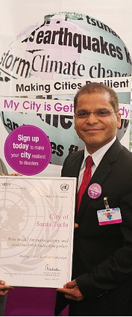
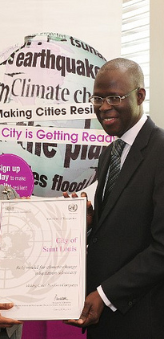
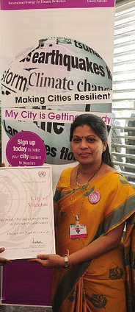
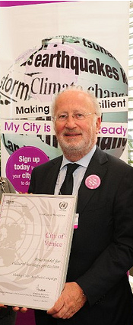
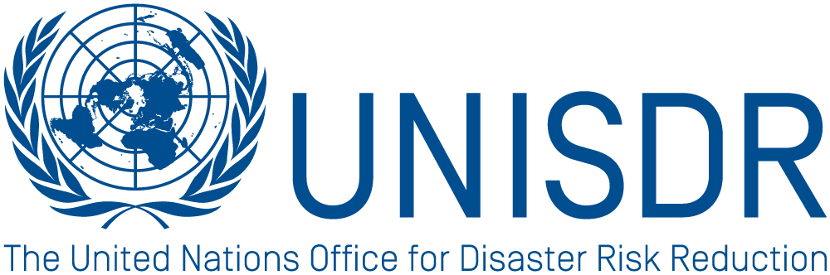
Making Cities Resilient: My City is Getting Ready

www.unisdr.org/campaign
ROLE MODEL GUIDELINES

How to sign up as a Role Model in the
Making Cities Resilient Campaign

Who is a Role Model?

Cities or local governments that are participating in the Campaign and have demonstrated good practices and innovation in disaster risk reduction and resilience can be nominated as a “Role Model” in the campaign.

Role Models are cities or local governments that demonstrate achievements in at least five areas out of the 10 Essentials in the “Ten-point checklist of Essentials for Making Cities Resilient” (Annex 1).

Role Model cities are innovators, creative, result oriented, inclusive and knowledgeable local governments willing to make a difference within the global community to strengthen the resilience concept with concrete actions.

Role Models can be nominated by:

- National government institutions dealing with disaster risk reduction issues;
- National government institutions dealing with local and urban development; or
- International partner in the Making Cities Campaign;
- another role model city;
UN agency working with a city in disaster risk reduction issues; or
- Private sector company that either is part of UNISDR PSP or works closely with a city in disaster risk reduction issues.

The nominated cities or local governments must show innovation, sustained results in reducing disaster risk and must be interested to showcase and share results.

How to become a role model city:

Step 1 - Join the Making Cities Resilient Campaign;
Step 2 - Review cities progress in risk reduction using the Local Government Self-assessment tool (HFA Local);
Step 3 - Get nominated ( see Role models can be nominated by:);
Step 4 - Submit nomination ( i.e nomination form and Recommendation letter);
Step 5 – Submit Motivation letter;

Submit nomination:

The nominating institution shall send, in addition to the nomination form (see Annex II and Annex III), a motivation letter to UNISDR explaining why this city or local government could serve as a Role Model in the campaign.

Nomination documents must also include a letter of recommendation from one of the institutions mentioned above supporting the nomination and confirming the results achieved by the local government.
Recognition and engagement in the campaign:

UNISDR will provide formal recognition to the nominated city as a Role Model in its area of strength.

Role Models will be featured in Making Cities Resilient reports and publicity material.

Role Models will:

- Share experiences with other cities by organizing city-to-city learning with study tours or training components;
- Prepare audiovisual material presenting innovative solutions for urban risk and local risk reduction, and organizing policy dialogues;
- Twin up with other cities to provide support;
- Report back to UNISDR once a year on achievements and be featured in reports on resilient cities;
- Role Models should provide technical assistance and lead on training for the use and implementation of the Local HFA-LGSAT, based on their experience with the tool.
- Role Models should help build awareness by sending a representative to attend at least one event per year and should help promoting and/or organizing and/or participating at the International DRR day in coordination with UNISDR. Key dates and events such as IDDRR, the Resilient Cities Summit, and other national/regional events should be used to advocate campaign messages, disseminate publications and other relevant information.
- Role Model focal point should provide one story per year (minimum) to be posted at the UNISDR Campaign website in their native language.
- Role Models should provide analysis of information, for reports case studies, etc according to their capacities, background and experience.
- Role Models should provide specific research if needed, according to their experience.
For more information visit: www.unisdr.org/campaign

Contact a UNISDR office in your region:

UNISDR Secretariat Geneva
E-mail: isdr-campaign@un.org

UNISDR Regional Office Africa, Nairobi
Email: isdr-africa@unep.org

UNISDR Regional Office Americas, Panama
Email: eird@eird.org

UNISDR Regional Office for Arab States, Cairo
Email: isdr-arabstates@un.org

UNISDR Regional Office Asia and Pacific, Bangkok
Email: isdr-bkk@un.org

UNISDR Regional Office Europe, Brussels
Email: isdr-europe@un.org

Annex I

A Ten-point checklist for local governments- Ten essentials for making cities resilient

The campaign offers a Ten-point checklist of Ten Essentials for Making Cities Resilient to serve as a guide for commitments.

Ten-point Checklist - Essentials for Making Cities Resilient¹

1. Put in place organization and coordination to understand and reduce disaster risk within the local government, based on participation of citizen groups and civil society. Build local alliances. Ensure that all departments understand their role and contribution to disaster risk reduction and preparedness.
2. Assign a budget for disaster risk reduction and provide incentives for homeowners, low-income families, communities, businesses and public sector to invest in reducing the risks they face.
3. Maintain up-to-date data on hazards and vulnerabilities, prepare risk assessments and use these as the basis for urban development plans and decisions. Ensure that this information and the plans for your city’s resilience are readily available to the public and fully discussed with them.
4. Invest in and maintain infrastructure that reduces risk, such as flood drainage, adjusted where needed to cope with climate change.
5. Assess the safety of all schools and health facilities and upgrade these as necessary.
6. Apply and enforce realistic, risk-compliant building regulations and land use planning principles. Identify safe land for low-income citizens and develop upgrading of informal settlements, wherever feasible.
7. Ensure education programmes and training on disaster risk reduction are in place in schools and local communities.
8. Protect ecosystems and natural buffers to mitigate floods, storm surges and other hazards to which your city may be vulnerable. Adapt to climate change by building on good risk reduction practices.
9. Install early warning systems and emergency management capacities in your city and hold regular public preparedness drills in which everyone participates.
10. After any disaster, ensure that the needs of the survivors are placed at the centre of reconstruction with support for them and their community organizations to design and help implement responses, including rebuilding homes and livelihoods.
¹ The Checklist builds on the priorities identified in the Hyogo Framework for Action 2005-2015: Building the Resilience of Nations and Communities to Disasters - www.unisdr.org/hfa
Annex II: Nomination Form for Role Models
Role Models will be actively promoted in the campaign. Each Role Model will be able to create an individual Role Model profile hosted on the campaign website with Role Model-specific elements, such as showcasing good practices in at least 5 essentials, and highlighting main achievements and potential for replication.

In addition to the nomination form (see Annex III), please provide the following information:

Select at least 5 essentials highlighting main achievements and good practices
Essential 1 – Risk reducing organization and coordination in place
Achievements/Good practices -
Essential 2 – Budget assigned
Achievements/Good practices -
Essential 3 – Risk assessment prepared
Achievements/Good practices -
Essential 4 – Investment in risk reducing infrastructure
Achievements/Good practices -
Essential 5 – Safe schools and health facilities
Achievements/Good practices -
Essential 6 – Risk-compliant building regulation and land use applied
Achievements/Good practices -
Essential 7 – Education programmes and training in place
Achievements/Good practices -
Essential 8 – Ecosystems and natural buffers protected
Achievements/Good practices -
Essential 9 – Early warning systems installed
Achievements/Good practices -
Essential 10 – Needs-based (survivors) reconstruction
Achievements/Good practices -
Partnerships
Please add major partner(s) and describe briefly the relationship and/or project with the partner.
Partner 1 -
Partner 2 -
Etc
Mayor´s Quote
Please provide a quote from the Mayor (no longer than 30 words) that describes the main achievement or the importance of disaster risk reduction.
Mayor’s Quote -
Please submit a photo of the Mayor, which will be uploaded to the campaign website.
Mayor’s photo:

Annex III

Nomination form for cities and local governments wishing to participate in the campaign
If the applicant is not already a member of the Making Cities Resilient campaign, please fill in the nomination form below and submit a letter signed by the mayor / local government leader confirming interest in participating in the campaign. An online submission form is also available on the campaign website: www.unisdr.org/campaign.

City / Local Government
(Please indicate the year if numbers are provided.)
City name
Province/State
Country
Size (year)
Population (year)
GDP
Hazard type(s)
Name of Mayor / Commissioner / Governor / Community leader
Which part of the city administration will be the focal point for the Campaign?
Contact details Focal Point
Name
Function
Address
Email
Telephone
Fax
Which local institutions will be engaged in the Campaign?
(In addition to the local government.)
Hazard and Vulnerability Profile
(Please indicate major disasters that have occurred, prevailing hazards and vulnerable conditions.)

World Disaster Reduction Campaign 2010-15, UNISDR Secretariat, E-mail: isdr-campaign@un.org

