Model Building Code
For Wind Loads

Final Version, May 2003



Association of Caribbean States © 2003
5-7 Sweet Briar Road, St. Clair, P.O. Box 660
Port of Spain, Trinidad and Tobago, West Indies
Tel: (868) 622 9575 | Fax: (868) 622 1653
http://www.acs-aec.org -- mail@acs-aec.org

The present model code is based on the Section 6 of the document Minimum Design Loads for Buildings and Other Structures (ASCE-7-02 © 2002) published by the American Society of Civil Engineers (ASCE). Figures and Tables of ASCE 7-02 are reproduced in Appendix I.

The material is reproduced by permission of the publisher, ASCE. It can be ordered at:
http://www.pubs.asce.org/ASCE7.html?9991330.

This model code was prepared by:

Dr. Myron W. Chin
&
Prof. Winston Suite
The University of the West Indies
Trinidad and Tobago

With the assistance of:

Prof. Dr. Carlos Llanes Burón
Instituto Superior Politecnico “José Antonio Echeverría”
Cuba

Prof. Ezio Faccioli
Politecnico di Milano
Italy

Prof. Gian Michele Calvi
Università di Pavia
Italy

Prof. Jorge Gutiérrez
&
Prof. Guillermo Santana
Universidad de Costa Rica
Costa Rica

TABLE OF CONTENTS

FOREWORD 9
I. SCOPE 13
1.1 Explicit Concepts 13
1.2 Performance Objectives - Hurricane Precautions 13
1.3 Specific Indications for Different Construction Types 14
1.4 Definitions 15
1.5 Symbols and Notations 18
II. WIND HAZARD 22
2.1 Basic Wind Speed 22
2.2 Topography 23
2.3 Height Above Ground Level 23
2.4 Terrain – Roughness 23
III. WIND DESIGN ACTIONS 25
3.1 Importance Classes and Factors 25
3.2 Scale Effects 25
3.3 Pressure (Internal and External) 26
3.4 Dynamic and Aeroelastic Effects (Gust Effects) 26
3.5 Directionality Effects 27
3.5.1 Combined Factored Loads Using Strength Design Applicability 28
3.5.2 Combined Nominal Loads Using Allowable Stress Design 28

IV. METHODS OF ANALYSIS 29
4.1 Method 1 – Simplified Procedure 29
4.1.1 Scope 29
4.1.2 Main Wind Force-Resisting Systems 29
4.1.3 Components and Cladding 30
4.1.4 Design Procedure 30
4.1.5 Main Wind Force-Resisting System 30
4.1.6 Components and Cladding 31
4.1.7 Air-Permeable Cladding 32
4.2 Method 2 – Analytical Procedure 32
4.2.1 Scope 32
4.2.2 Limitations 32
4.2.3 Shielding 32
4.2.4 Air-Permeable Cladding 32
4.2.5 Design Procedure 33
4.2.6 Basic Wind Speed 33
4.2.7 Special Wind Regions 33
4.2.8 Estimation of Basic Wind Speeds from Regional Climatic Data 34
4.2.9 Limitation 34
4.2.10 Wind Directionality Factor 34
4.2.11 Importance Factor 34
4.2.12 Exposure 34
4.2.13 Wind Directions and Sectors 35
4.2.14 Surface Roughness Categories 35
4.2.15 Exposure Categories 35
4.2.16 Exposure Category for Main Wind Force-Resisting Systems 36
4.2.16.1 Buildings and other Structures 36
4.2.16.2 Low-Rise Buildings 36
4.2.17 Exposure Category for Components and Cladding 36
4.2.17.1 Buildings with Mean Roof Height h less than or equal to 18 m 36
4.2.17.2 Buildings with Mean Roof Height h greater than 18 m and Other Structures 36
4.2.18 Velocity Pressure Exposure Coefficient 37
4.2.19 Topographic Effects 37
4.2.19.1 Wind Speed-Up Over Hills, Ridges and Escarpments 37
4.2.19.2 Topographic Factor 37
4.2.20 Gust Effect Factor 38
4.2.20.1 Rigid Structures 38
4.2.20.2 Flexible or Dynamically Sensitive Structures 38
4.2.20.3 Rational Analysis 39
4.2.20.4 Limitations 40
4.2.21 Enclosure Classifications 40
4.2.21.1 General 40
4.2.21.2 Openings 40
4.2.21.3 Wind-Borne Debris 40
4.2.21.4 Multiple Classifications 41
4.2.22 Velocity Pressure 41
4.2.23 Pressure and Force Coefficients 41
4.2.23.1 Internal Pressure Coefficients 41
4.2.23.1.1 Reduction Factor for Large Volume Buildings, Ri 41
4.2.23.2 External Pressure Coefficients 42
4.2.23.2.1 Main Wind Force-Resisting Systems for Main Force-Resisting Systems 42
4.2.23.2.2 Components and Cladding 42
4.2.23.3 Force Coefficients 42
4.2.23.4 Roof Overhangs 42
4.2.23.4.1 Main Wind Force-Resisting System 42
4.2.23.4.2 Components and Cladding for Roof Overhangs 42
4.2.23.5 Parapets 43
4.2.23.5.1 Main Wind Force-Resisting System for Parapets 43
4.2.23.5.2 Components and Cladding for Parapets 43
4.2.24 Design Wind Loads on Enclosed and Partially Enclosed Buildings 43
4.2.24.1 General 43
4.2.24.1.1 Sign Convention 43
4.2.24.1.2 Critical Load Condition 43
4.2.24.1.3 Tributary Areas Greater than 65 m² (700 ft²) 43
4.2.24.2 Main Wind Force-Resisting Systems 43
4.2.24.2.1 Rigid Buildings of all Height 43
4.2.24.2.2 Low-Rise Buildings 44
4.2.24.2.3 Flexible Buildings 44
4.2.24.2.4 Parapets 45
4.2.24.3 Design Wind Load Cases 45
4.2.24.4 Components and Cladding 46
4.2.24.4.1 Low-Rise Buildings and Buildings with h ≤ 18.3 m (60 ft) 46
4.2.24.4.2 Buildings with h > 18.3 m (60 ft) 46
4.2.24.4.3 Alternative Design Wind Pressures for Components and Cladding in Buildings with 18.3 m (60 ft)< h < 27.4 m (90 ft) 47
4.2.24.4.4 Parapets 47
4.2.25 Design Wind Loads on Open Buildings and Other Structures 47
4.3 Method 3 – Wind Tunnel Procedure 48
4.3.1 Scope 48
4.3.2 Test Conditions 48
4.3.3 Dynamic Response 49
4.3.4 Limitations 49
4.3.4.1 Limitations on Wind Speeds 49
V. INDUCED EFFECTS 50
5.1 Impact of Flying Objects 50
5.2 Wind-Borne Debris 50
5.3 Wind Driven Rain 52
5.3.1 Design Wind Driven Rain Loads 52
5.3.2 Ponding Instability 52
5.3.3 Controlled Drainage 52
VI. SAFETY VERIFICATIONS 54
6.1 Structure 54
6.2 Claddings and Non-Structural Elements 55
VII. SIMPLE BUILDINGS 56
7.1 Scope 56
7.1.1 Definition of ‘Simple’ Building 56
7.1.2 Components and Cladding 57
7.2 Design and Safety Verifications 57
REFERENCES 58
APPENDIX I 59

FOREWORD

Introduction

Recognising the need for each country susceptible to disasters to have appropriate construction standards, the Association of Caribbean States (ACS), with financial assistance from the Government of Italy, through its Trust Fund managed by the Inter-American Development Bank (IDB), and from STIRANA (Foundation for Disaster Preparedness of the Netherlands Antilles), has embarked on a project aimed at “Updating Building Codes of the Greater Caribbean for Winds and Earthquakes” and thereby reducing the vulnerability to natural disasters. This initiative is consistent with the goal of the ACS Special Committee on Natural Disasters to reduce risks and losses caused by natural disasters in ACS Members Countries.

The objective of the first phase of the project was to produce and disseminate state-of-the-art model codes for wind loads and earthquakes as well as recommendations for the updating of existing codes, so that ACS Member Countries be able to endow themselves with new appropriate codes or improve the existing ones, in order to develop better construction practices and techniques for the building of safe and reliable buildings.

Evaluation of Existing Building Codes in the Greater Caribbean

The first part of the project was devoted to a thorough analysis of the situation of present wind code provisions in ACS Spanish- and English-speaking Member Countries. To accomplish this task, ad-hoc Evaluation Forms were prepared, the entries of which included all the main items that should be found in a state-of-the-art code. Subsequently, the existing wind code provisions of ACS Spanish- and English-speaking Member Countries were thoroughly reviewed and evaluated, and the Forms were completed. At the end of each Evaluation Form, salient recommendations for code improvement were formulated. The Forms were finally disseminated to ACS Member Countries.

An extremely diversified situation emerged from the analysis.

Preparation of a Model Code

In the second part of the project a Model Codes was drafted, to be used by each State in updating/preparing actual Codes of Practice, inspired by common concepts.

Given the diversity of the situations in each country, the project team decided to prepare a conceptual model code that would not only be complete in its scope, but also capable of allowing the development of actual codes of practice at different levels of complexity.
This step required a clear distinction between principles, to be adopted as the basis of design and safety rules, and recommendations to implement these principles into practical rules.

The conceptual choice of the model code implied that no reference to specific construction materials and structural systems should be made, since these should be treated at a national or regional level.

These decisions were implemented adopting as a basic reference document the American Society of Civil Engineers (ASCE) ASCE 7-02 Wind Loads, as the basic reference document, since a number of Caribbean States have utilised it in their existing wind codes.

This Model Code therefore consists of two parts:

- The present document, and
- Section 6 of ASCE 7-02 as the basic reference document.

In this regard the numbering of Figures and Tables in the present document has been maintained as those given in ASCE 7-02 for ease of reference. These are reproduced in Appendix I. Please note Figure 6-1 has not been included in this model code as it is not applicable to the Greater Caribbean territories.

A National Application Document (NAD) is to be developed by each country to reflect both the peculiarities of geography and topography as well as the local construction practice.

The NAD shall provide complementary information to assist the user to apply the Model Code in the design of buildings to be constructed, as well as for the retrofitting of existing buildings in the Greater Caribbean areas.

Due to its conceptual basis, the Model Code is intended for use by code makers and authorities, not by single professionals.

Normative References

Each NAD may incorporate, by reference, provisions from specific editions of other publications.

Informative References

The NAD may also refer to other publications that provide information or guidance. Each Edition of these publications current at the time of issue of this NAD should be listed.

Wind Speed Maps

The wind speed map referred to in the Model Code should be enforced at a State level, but should be possibly based on global comprehensive and consistent scientific studies for the entire Greater Caribbean Region, to avoid inconsistency at the borders between different states. It is therefore recommended that a “model wind speed map” be developed for the entire Caribbean region.

Wind speed maps shall be developed using internationally accepted methods, up-to-date data and transparent and repeatable procedures. Periodic revisions should be foreseen.

Enforcing and Monitoring the Use of a Code

Countries of the Greater Caribbean Region should give priority to the strengthening of existing building codes or the development of new codes.

However, the development of relatively advanced national codes based on the present model code will not automatically produce a reduction of wind risk. Such reduction requires adequate measures to enforce the use of the code, to monitor its performance, to increase the level of understanding and the specific preparation of professionals and consultants.

Enforcing the use of a code requires making its application mandatory, implying therefore some sort of control of the application of the code in designing, assessment and strengthening, through the creation of enforcement and inspection mechanisms. This objective may be pursued by defining strategies and creating special offices in charge of collecting design data, responding to technical questions, and checking the actual and appropriate use of the code in given fractions of the designed and constructed cases. Such fractions of the designed building stock to be checked may be defined for different building importance categories (e.g.: 5 % for importance class IV, 10 % for importance class III, 50 % for importance class II, 100% for importance class I).

To reinforce these building regulations, governments should work with private-sector financial and insurance companies to encourage the development of financial incentives, such as premium reductions or reduced-rate loans, for properly constructed buildings using established standards and regulations.

Education and Dissemination

The importance of assuring a high level of competence of the designers cannot be overemphasized. With the adoption of state-of-the-art building codes throughout the region, building inspectors, designers, engineers, builders and construction workers have to be trained on the new codes. Control measures for the training and the qualification of those actors should also be put in place. It is therefore recommended that all means of increasing the understanding of concepts and rules defined in the codes be exploited. Appropriate measures may include organization of short courses, possibly using e–learning tools, preparation of manuals and on–line helping tools, periodical verification of the effective competence of professionals.

Periodic Revisions

It is recommended that a procedure be established for the periodic updating of the model and national codes, based on scientific progress and on the results of the monitoring process. These revisions should be considered at time intervals of approximately 5 years with a maximum of 10 years.

SCOPE

Explicit Concepts

This model code is intended for the design and construction of new buildings, as well as retrofitting of existing buildings subjected to wind loads.

The principal reference code is Section 6.0 of the ASCE-7-02.

The model code is not intended to supersede or amend legislation enforced in any country since this will be the effect of each appropriate NAD. Users of this model code must consult other listed legislation. The model code describes the action of wind on structures and methods for calculating characteristic values of wind loads for use in the design of buildings and related structures as well as their components and appendages.

Performance Objectives - Hurricane Precautions

It is very important in the Caribbean to be ever conscious of the fact that the region lies within the customary hurricane path. During such periods of time as are designated by the Government as being under hurricane warning, the owner, occupant or user of a property shall take precautions for the securing of buildings and equipment, preferably according to a previously established plan of measures against catastrophes starting from studies of risk.

The elements of buildings most vulnerable to hurricane forces are roofs, windows and walls. The objective of hurricane resistant construction is to provide a building that will not collapse during a hurricane. The building must be standing and its occupants should be safe.

Rules for construction of hurricane resistant buildings must cover the following issues:

- Building site (selection)
- Roof structure (structure, shape, components and attachment/fastening)
- Windows and Doors
- Walls
- Openings and Claddings
- Interaction with other neighboring structures

In addition these rules shall be specific to the various building materials such as in the following examples:
- Timber buildings
- Steel buildings
- Reinforced concrete buildings

Building Location: Buildings sited in exposed areas are most vulnerable.

Roofs: Since experience and research have shown that flat roofs are vulnerable to high winds, the roof pitch should preferably not be less than 25 to 30 degrees. Hip roofs should be used as these are more hurricane resistant than gable roofs. Roof overhangs also experience high level pressures and, where possible, these should be kept to a minimum or removed.

Openings, Claddings The experience has shown that the existence of openings and interaction with and neighboring buildings produce variations of other neighboring structures: consideration in the behavior of the wind pressures on the buildings so much external as inwardly.

Specific Indications for Different Construction Types

Timber Buildings: The entire structure must be fastened to the foundation and tied together with timber braces and hurricane straps. The properties of commonly used timber will have to be researched and catalogued to assist designers in the region in the use of indigenous timbers.

Steel Buildings: Undersized sections and poor maintenance have led to significant reduction in the size of critical sections and hence failure. Holding down bolts are needed to tie the structure to the foundation.

Reinforced Concrete All walls shall be finished at the top by a reinforced concrete Buildings: ring beams not less than 200 mm in depth.
The minimum ring beam reinforcement shall be four 12 mm diameter bars with 6 mm diameter stirrups placed at 300 mm between centres. The beam width shall be a minimum of 150 mm without plaster.

Definitions

The following definitions shall apply to the provisions of this model wind code.

Approved Acceptable to the authority having jurisdiction.

Basic Wind Speed, V 3-second gust speed at 10 m (33 ft) above the ground in Exposure C (see Section 4.2.15) as determined in accordance with Section 4.2.6. It may be necessary in some countries to use other wind speed measures and in these cases careful correction is necessary.

Building Enclosed A building that does not comply with the requirements for open or partially enclosed buildings.

Building Envelope Cladding, roofing, exterior walls, glazing, door assemblies, window assemblies, skylight assemblies, and other components enclosing the building.

Building and Other Slender buildings and other structures that have a fundamental Structure, Flexible natural frequency less than 1 Hz.

Building, Low-Rise Enclosed or partially enclosed buildings that comply with the following conditions:

- Mean roof height h less than or equal to18 m (60 ft); and
- Mean roof height h does not exceed least horizontal dimension.

Building, Open A building having each wall at least 80%. This condition is expressed for each wall by the equation A_{o} ≥ 0.8 A_{g},
where
A_{o} = total area of openings in a wall that receives positive external pressure, in m² (ft²)
A_{g} = the gross area of that wall in which Ao is identified, in m² (ft²)

Building, A building that complies with both of the following conditions: Partially Enclosed
- The total area of openings in a wall that receives positive external pressure exceeds the sum of the areas of openings in the balance of the building envelope (walls and roof) by more than 10%, and
- The total area of openings in a wall that receives positive external pressure exceeds 0.37 m² (4 ft²) or 1% of the area of that wall, whichever is smaller, and the percentage of openings in the balance of the building envelope does not exceed 20%.

These conditions are expressed by the following equations:

- A_{o} > 1.10 A_{oi}
- A_{o} > 0.37 m² (4 ft²) or > 0.01 A_{g}, whichever is smaller, and A_{oi}/A_{gi} ≤ 0.20
where
A_{o}, A_{g} are as defined for Open Building
A_{oi} = the sum of the areas of openings in the building envelope (walls and roof) not including A_{o}, in m² (ft²)

Building or other A building or other structure having no unusual geometrical structure, regular irregularity in spatial form.
shaped

Building or other A building or other structure whose fundamental structures, rigid frequency is greater than or equal to 1 Hz.

Building, Simple An enclosed or partially enclosed building in which Diaphragm: wind loads are transmitted through floor and roof diaphragms to the vertical main wind force-resisting system.

Components Elements of the building envelope that do not qualify as part of and Cladding the main wind force-resisting system.

Design Force, F Equivalent static force to be used in the determination of wind loads for open buildings and other structures.

Design Pressure, p Equivalent static pressure to be used in the determination of wind loads for buildings.

Effective Wind Area The area used to determine GC_{p}, For component and cladding elements, the effective wind area in Figures 6-11 through 6-17 is the span length multiplied by an effective width that need not be less than one-third the span length. For cladding fasteners, the effective wind area shall not be greater than the area that is tributary to an individual fastener.
Escarpment Also known as scarp, with respect to topographic effects in Section 4.2.19, a cliff or steep slope generally separating two levels or gently sloping areas (see Figures 6-4).

Glazing Glass or transparent or translucent plastic sheet used in windows, doors, skylights, or curtain walls.

Glazing, Glazing that has been shown by testifying in accordance with Impact Resistant ASTM 1886 [1] and ASTM 1996 [2] or other approved test methods to withstand the impact of wind-borne missiles likely to be generated in wind-borne debris regions during design winds.

Hill With respect to topographic effects in Section 4.2.19, a land surface characterized by strong relief in any horizontal direction (see Figures 6-4).

Hurricane- Areas vulnerable to hurricanes in the Greater Caribbean defined Prone Regions: as:
All countries bounded by or situated within the Caribbean Sea where the basic wind speed is greater than 145 km/h (90 mph).

Impact-Resistant A covering designed to protect glazing, which has been shown Covering by testing in accordance with ASTM E 1886 [1] and ASTM 1996 [2] or other approved test methods to withstand the impact of wind-borne debris missiles likely to be generated in wind- borne debris regions during design winds.

Importance Factor, I. A factor that accounts for the degree of hazard to human life and damage to property.

Main Wind An assemblage of structural elements assigned to provide Force-Resisting System support and stability for the overall structure. The system generally receives wind loading from more than one surface.

Mean Roof Height, h The average of the roof eave height and the height to the highest point on the roof surface, except that, for roof angles of less than or equal to 10 degrees, the mean roof height shall be the roof eave height.

Openings Apertures or holes in the building envelope that allow air to flow through the building envelope and that are designed as “open” during design winds as defined by these provisions.
Recognized Literature Published research findings and technical papers that are approved.

Ridge With respect to topographic effects in Section 4.2.19, an elongated crest of a hill characterized by strong relief in two directions (see Figures 6-4).

Wind-Borne Debris Areas within hurricane-prone regions located
Regions.
  - Within 1610 m (1 mile) of the coastal mean high water line where the basic wind speed is equal to or greater than 177 km/h (110 mph), or
  - In areas where the basic wind speed is equal to or greater than 193 km/h (120 mph).

Symbols and Notations

The following symbols and notations shall apply only to the provisions of this model wind code.

A = Effective wind area, in m² (ft²).
A_{f} = Area of open buildings and other structures either normal to the wind direction or projected on a plane normal to the wind direction, in m² (ft²).
A_{g} = The gross area of that wall in which A_{o} is identified, in m² (ft²).
A_{gi} = The sum of the gross surface areas of the building envelope (walls and roof) not including A_{g}, in m² (ft²).
A_{o} = Total area of openings in a wall that receives positive external pressure, in m² (ft²).
A_{oi} = The sum of the areas of openings in the building envelope (walls and roof) not including A_{o}, m² (ft²).
A_{og} = Total area of openings in the building envelope m² (ft²).
a = Width of pressure coefficient zone, in m (ft).
B = Horizontal dimension of building measured normal to wind direction, in m (ft).
b = Mean hourly wind speed factor in Eq. 4.14 from Table 6-2.
b = 3-second gust speed factor from Table 6-2.
C_{f} = Force coefficient to be used in determination of wind loads for other structures.
C_{p} = External pressure coefficient to be used in determination of wind loads for buildings.
c = Turbulence intensity factor in Eq. 4.5 from Table 6-2.
D = Diameter of a circular structure or member, in m (ft).
D' = Depth of protruding elements such as ribs and spoilers, in m (ft).
G = Gust effect factor.
G_{f} = Gust effect factor for main wind force-resisting systems of flexible buildings and other structures.
GC_{pn} = Combined net pressure coefficient for a parapet.
GC_{p} = Product of external pressure coefficient and gust effect factor to be used in determination of wind loads for buildings.
GC_{pf} = Product of the equivalent external pressure coefficient and gust effect factor to be used in determination of wind loads for main wind force-resisting system of low-rise buildings.
GC_{pi} = Product of internal pressure coefficient and gust effect factor to be used in determination of wind loads for buildings.
g_{Q} = Peak factor for background response in Eqs. 4.4 and 4.8.
g_{R} = Peak factor for resonant response in Eq. 4.8.
g_{v} = Peak factor for wind response in Eqs. 4.4 and 4.8.
H = Height of hill or escarpment in Figures 6-4, in m (ft).
h = Mean roof height of a building or height of other structure, except that eave height shall be used for roof angle θ of less than or equal to 10 degrees, in m (ft).
I = Importance factor.
Iz = Intensity of turbulence from Eq. 4.5.
K₁, K_{2,} K₃ = Multipliers in Figure 6-4 to obtain K_{zt}.
K_{d} = Wind directionality factor in Table 6-4.
K_{h} = Velocity pressure exposure coefficient evaluated at height z = h (Height Coefficient).
K_{z} = Velocity pressure exposure coefficient evaluated at height z.
K_{zt} = Topographic factor.
L = Horizontal dimension of a building measured parallel to the wind direction, in m (ft).
L_{h} = Distance upwind of crest of hill or escarpment in Figure 6-4 to where the difference in ground elevation is half the height of hill or escarpment, in m (ft).
L_{z} = Integral length scale of turbulence, in m (ft).
$ℓ$ = Integral length scale factor from Table 6-2, m (ft).
M = Larger dimension of sign, in m (ft).
N = Smaller dimension of sign, in m (ft).
N₁ = Reduced frequency from Eq. 4.12.
n₁ = Building natural frequency, Hz.
p = Design pressure to be used in determination of wind loads for buildings, in N/m² (lb/ft²).
p_{L} = Wind pressure acting on leeward face in Figure 6-9.
p_{net30} = Net design wind pressure for exposure B at h = 30 ft ≈ 9 m. and I = 1.0 from Figure 6-3.
p_{p} = Combined net pressure on a parapet from Eq. 4.20.
p_{s30} = Simplified design wind pressure for exposure B at h = 30 ft and I = 1.0 from Figure 6-2.
p_{w} = Wind pressure acting on windward face in Figure 6-9.
Q = Background response factor from Eq. 4.6.
q = Velocity pressure, in N/m² (lb/ft²).
q_{h} = Velocity pressure evaluated at height z = h, in N/m² (lb/ft²).
q_{i} = Velocity pressure for internal pressure determination.
q_{p} = Velocity pressure at top of parapet.
q_{z} = Velocity pressure evaluated at height z above ground, in N/m² (lb/ft²).
R = Resonant response factor from Eq. 4.10.
R_{B,} R_{h}, R_{L} = Values from Eq. 4.13.
R_{i} = Reduction factor from Eq. 4.16.
R_{n} = Value from Eq. 4.11.
V = Basic wind speed obtained from the national basic wind speed zonation map of each country, in m/s (mph). The basic wind speed corresponds to a 3-second gust speed at 10 m (33 ft) above ground in Exposure Category C.
V_{i} = Unpartitioned internal volume m³ (ft³)
V_{z} = Mean hourly wind speed at height z, m/s (ft/s).
W = Width of building in Figures 6-12, and 6-14A and B and width of span in Figures 6-13 and 6-15, in m (ft).
X = Distance to center of pressure from windward edge in Figure 6-18, in m (ft).
x = Distance upwind or downwind of crest in Figure 6-4, in m (ft).
z = Height above ground level, in m (ft).
z = Equivalent height of structure, in m (ft).
z_{g} = Nominal height of the atmospheric boundary layer used in this standard. Values appear in Table 6-2.
z_{min} = Exposure constant from Table 6-2.
α = 3-sec gust speed power law exponent from Table 6-2.
α = Reciprocal of α from Table 6-2.
α = Mean hourly wind speed power law exponent in Eq. 4.14 from Table 6-2.
β = Damping ratio, percent critical for buildings or other structures.
ε = Ratio of solid area to gross area for open sign, face of a trussed tower or lattice structure.
λ = Adjustment factor for building height and exposure from Figures 6-2 and 6-3.
ε = Integral length scale power law exponent in Eq. 4.7 from Table 6-2.
η = Value used in Eq. 4.13 (see Section 4.2.20.2).
θ = Angle of plane of roof from horizontal, in degrees.
ν = Height-to-width ratio for solid sign.

WIND HAZARD

Buildings and structures shall be designed and constructed to resist the forces due to wind pressure.

The forces exerted by the wind are the result of a combination of factors such as:

(i) Wind speed
(ii) Exposure factor
(iii) Aerodynamic shape of the structure
(iv) Dynamic response factor

All structural systems shall be designed and constructed to transfer wind forces to the ground.

Basic Wind Speed

The basic wind speed, V, for the determination of the wind load shall be determined in accordance with the provisions of this Model Wind Code.

A basic wind speed zonation map for each territory shall be established (where this does not already exist or where it is not consistent with this Code). This will assist in classification according to the Basic Wind Speed which will be used to develop values of velocity pressures.

The wind forces per unit area on a structure may be determined from a relationship of the general form:

Velocity pressure, q_{z}, evaluated at a height, z, is given by Eq. 4.15 i.e.:

q_{z} = 0.613 K_{z} K_{zt} K_{d} V² I (N/m²)

where V in m/s
K_{d} = wind directionality factor determined from Table 6-4
K_{z} = velocity pressure exposure coefficient determined from Table 6-3.
K_{zt} = topographic factor given by Eq. 4.3
I = importance factor determined from Table 6-1

The wind speed-up effect shall be included in the calculation of design wind loads by using the factor K_{zt}.
The basic wind speed, V, is obtained from a proper zonation map and corresponds to a 3 second gust speed at 10 m above ground in Exposure Category C, corresponding to a probability of exceedance 2% in a return period of 50 years.

The numerical coefficient in equation (4.15) shall be used except where sufficient climatic data are available to justify selection of a different value of this factor for a design application.

Topography

The Exposure Factor, K_{zt}, accounts for the variability of velocity pressure at the site of the structure due to the following:

(a) Height above ground level
(b) Roughness of the terrain, and
(c) In undulating terrain, the shape and slope of the ground.

A Wind Topography Factor, K_{zt}, will be considered when the structure is located on a hill or elevation capable of increasing the windward wind velocity at 10 m above ground. K_{zt} will be taken as 1.0 if

H/L_{n} < 0.2
H < 9 m for Exposure Category B
H < 18.0 m for Exposure Category C

where H = Height of hill
L_{n} = Upwind width of the hill at mid height

Height Above Ground Level

The velocity pressure exposure coefficients, K_{h} and K_{z} are functions of height above ground and the exposure categories A, B, C, D and are defined in table 6-3 and section 2.4.

Terrain – Roughness

Four exposure categories are defined.

(i) Exposure Category A

Large City Centres with at least 50% of the buildings with heights more than 20 m.
(ii) Exposure Category B

Urban and suburban areas, wooded areas, other terrain with numerous closely spaced obstructions having the size of single family dwellings or larger having average heights less than 10 m.

Exposure B shall apply where the ground surface roughness condition prevails in the upwind direction for a distance of at least 800 m or 10 times the height of the building, whichever is greater.

(iii) Exposure Category C

Open terrain, plains and savannahs with scattered obstructions having average heights less than 10 m.

Exposure C shall apply for all cases where exposure B or D do not apply.

(iv) Exposure Category D

Flat unobstructed coastal areas exposed to wind flowing from the open ocean for a distance of at least 1610 m (1 mile).

WIND DESIGN ACTIONS

Importance Classes and Factors

Buildings are classified into four importance categories:

Category I Buildings and related structures whose failure implies low risk for human life including but not limited to rural, storage or temporary facilities.
Category II Normal occupancy public or private buildings (housing, offices, commerce, etc.). Additionally, it includes hazardous facilities not classified as Category III if it is insured that any damage or toxic spill can be immediately controlled.
Category III Hazardous facilities or high occupancy public or private buildings.
Category IV Essential facilities such as hospitals, fire and police stations and designated hurricane shelters.

An importance factor shall be assigned to each class (See Table 7-2):

Category I I = 0.77 or 0.87
Category II I = 1.0
Category III I = 1.15
Category IV I = 1.15

The wind force per unit area is assumed to act statically in a direction normal to the surface of the structure or element except where others were specified e.g. with tangential functional forces.

Both internal and external forces must be considered.

Resonance may amplify the responses to the forces on certain wind sensitive structures. Such structures are characterised by their lightness, flexibility and low level of structural damping.

Scale Effects

In Enclosed, Partially enclosed buildings the external pressure coefficients, C_{p} for walls and roofs may be reduced for scale effects as given in Figure 6-6 when the main wind force resisting system is calculated by Method 2.

Pressure (Internal and External)

In order to estimate the internal pressure coefficient, buildings are classified as Enclosed, Partially Enclosed or Open.

The design pressure, p, for primary systems in Enclosed or Partially Enclosed Structures is defined by the following equation that takes into consideration the internal pressures.

(i) Rigid Building of all Heights:

The design pressure shall be determined by Eq. 4.17
The.design pressure, p, for primary systems in Enclosed or Partially Enclosed buildings shall not be less than 480 N/m².

For secondary systems in Enclosed or Partially Enclosed buildings, the design pressure p is defined as:

P = q_{h} [(GC_{p}) – (GC_{pi})] for structures with h ≤ 18 m

P = q[(GC_{p}) – (GC_{pi})] for structures with h > 18 m

For primary or secondary systems in Open buildings, p is given by the expression:

P = q_{z} GC_{p}

GC_{pi} shall be determined from Figure 6-5 based on building enclosure classification.

(ii) Low-Rise Buildings

The design pressure shall be determined by equation 4.18.

(iii) Flexible Buildings

The design pressure shall be determined by equation 4.19.

Dynamic and Aeroelastic Effects (Gust Effects)

For the definition of wind pressures, buildings are classified according to the geometry of their exposed areas in four Structural Types:

Type I: Enclosed buildings with a slenderness ratio less than 5 or natural period less than 1 s that are insensitive to gusts and other dynamic wind effects. Also includes buildings enclosed with laminated sheets, with one or more open facades (industrial warehouses, theatres, auditoriums, etc.).

Type II: Open buildings with a slenderness ratio less than 5 or natural period less than 1 s such as towers, guyed or free standing antennas, elevated tanks, commercial signs and parapets.

Type III: Buildings particularly sensitive to short duration gusts. Includes all buildings considered as Type I or Type II but with a slenderness ratio greater than 5 or natural period larger than 1 s as well as those whose geometry can induce strong vibrations.

Type IV: This group includes all structures with specific aerodynamic problems such as suspended roofs, unstable aerodynamic forms, flexible structures having natural periods closed to each other, etc.

For downwind surfaces, the pressure q_{h} (as well as K_{h}) is taken as constant along the entire height and corresponds to the value calculated for a height, h, equal to the medium roof height for buildings Type I or total building height for the other building types.

Wind pressures p and forces F are related to the Dynamic Wind Pressure q, the Gust Effect Factors G_{h} and G_{z} and the Shape Coefficients for external C_{pe} and internal pressures C_{pi} as well as C_{f} for roofs of open building and non-building structures.

For rigid structures the Gust Effect Factor, G, shall be taken as 0.85 here the natural period T ≤ 1 sec.

For flexible structures (natural period T > 1 sec) or for wind sensitive structures, the design pressure p is determined by equation 4.19.

Directionality Effects

The wind should be considered as coming horizontally from any direction, therefore the building has to be analysed with the wind acting parallel to its two principal directions. The Wind Directionality Factor, K_{d}, varies from 0.85 to 0.95 and shall be determined from Table 6-4. This factor shall only be applied when used in conjunction with specific load combinations (Sections 3.5.1 and 3.5.2) otherwise it should be taken as equal to unity.

Combined Factored Loads Using Strength Design Applicability

The load combination and load factors shall be used only in those cases in which they are specifically authorised by the applicable material design standards.

Structures, components and foundations shall be designed so that their design strengths equal or exceed the effects of the factored loads in the following combinations:

1. 1.4 (D + F)
2. 1.2 (D + F + T) + 1.6(L + 1 t) + 0.5 (L_{r} or S or R)
3. 1.2D + 1.6(L_{r} or S or R) + (0.5 L or 0.8 W)
4. 1.2D + 1.6W + 0.5L + 0.5(L_{r} or S or R)
5. 1.2D + 1.0E + 0.5L + 0.2S
6. 0.9D ++ 1.6W + 1.6H
7. 0.9D + 1.0E + 1.6H

Combined Nominal Loads Using Allowable Stress Design

Load listed herein shall be considered to act in the following combination, whichever produces the most unfavourable effect in the buildings:

1. D
2. D + L + F + H + T + (L_{r} or S or R)
3. D + (W or 0.7E) + L + (L_{r} or S or R)
4. 0.6D + W + H
5. 0.6D + 0.7E + H

where D = dead load
E = earthquake load
F = load due to fluids with well-defined pressures and maximum heights
Fa = flood load
H = load due to lateral earth pressure, ground water pressure, or pressure of bulk materials
L = live load
Lr = roof live load
R = rain load
S = snow load
T = self-straining force
W = wind load

METHODS OF ANALYSIS

Method 1 – Simplified Procedure

Scope

A building whose design wind loads are determined in accordance with this Section shall meet all the conditions of 4.1.2 or 4.1.3. If a building qualifies only under 4.1.3 for design of its components and cladding, then its main wind force-resisting system shall be designed by Method 2 or Method 3.

Main Wind Force-Resisting Systems

For the design of main wind force-resisting systems the building must meet all of the following conditions:

1. The building is a simple diaphragm building as defined in Section 1.4.
2. The building is a low-rise building as defined in Section 1.4.
3. The building is enclosed as defined in Section 1.4 and conforms to the wind-borne debris provisions of Section 4.2.21.3.
4. The building is a regular shaped building or structure as defined in Section 1.4.
5. The building is not classified as a flexible building as defined in Section 1.4.
6. The building does not have response characteristics making it subject to across-wind loading, vortex shedding, instability due to galloping or flutter; and does not have a site location for which channeling effects or buffeting in the wake of upwind obstructions warrant special consideration.
7. The building structure has no expansion joints or separations.
8. The building is not subject to the topographic effects of 4.2.19 (i.e. K_{zt} = 1.0).
9. The building has an approximately symmetrical cross section in each direction with either a flat roof, or a gable or hip roof with θ ≤ 45 degrees.

Components and Cladding

For the design of components and cladding the building must meet all the following conditions:

1. The mean roof height h ≤ 18 m (60 ft).
2. The building is enclosed as defined in Section 1.4 and conforms to the wind-borne debris provisions of Section 4.2.21.3.
3. The building is a regular shaped building or structure as defined in Section 1.4.
4. The building does not have response characteristics making it subject to across-wind loading, vortex shedding, instability due to galloping or flutter; and does not have a site location for which channeling effects or buffeting in the wake of upwind obstructions warrant special consideration.
5. The building is not subject to the topographic effects of Section 4.2.19 (i.e. K_{zt} = 1.0).
6. The building has either a flat roof, or a gable roof with θ ≤ 27 degrees.

Design Procedure

1. The basic wind speed V shall be determined in accordance with Section 4.2.6. The wind shall be assumed to come from any horizontal direction.
2. An importance factor I shall be determined in accordance with Section 4.2.11.
3. An exposure category shall be determined in accordance with Section 4.2.12.
4. A height and exposure adjustment coefficient, λ, shall be determined from Figure 6-2.

Main Wind Force-Resisting System

Simplified design wind pressure, p_{s}, for the main wind force-resisting systems of low-rise simple diaphragm buildings represent the net pressures (sum of internal and external) to be applied to the horizontal and vertical projections of building surfaces as shown in Figure 6-2. For the horizontal pressures (Zones A, B, C, D), p_{s} is the combination of the windward and leeward net pressures. p_{s} shall be determined by the following equations:

p_{s} = λ I p_{s30} (4.1)

where λ = adjustment factor for building height and exposure from Figure 6-2
I = importance factor as defined in Section 1.4.
p_{s30}= simplified design wind pressure for exposure B, at h = 9 m (30 ft), and for I = 1.0 from Figure 6-2.

Minimum Pressures for Wind Free-Resisting System:

The load effects of the design wind pressures from Section 4.1.5 shall not be less than the minimum load case from Section 3.3 assuming the pressures, p_{s}, for Zones A, B, C and D all equal to + 479 N/m² (10 psf), while assuming Zones E, F, G and H all equal to 0 N/m² (psf).

Components and Cladding

Net design wind pressure, p_{net}, for the components and cladding of buildings designed using Method 1 represent the net pressures (sum of internal and external) to be applied normal to each building surface as shown in Figure 6-3.

p_{net} shall be determined by the following equation:

p_{net} = λ I p_{net30} (4.2)

where λ = adjustment factor for building height and exposure from Figure 6-3.
I = importance factor as defined in Section 1.4.
p_{net30} = net design wind pressure for exposure B, at h = 9 m (30 ft), and for I = 1.0 from Figure 6-3.

Minimum Pressures for Components and Cladding:

The positive design wind pressures, p_{net}, from Section 4.1.6 shall not be less than + 479 N/m² (10 psf), and the negative design wind pressures, p_{net}, from 4.1.6 shall not be less than – 479 N/m² (10 psf).

Air-Permeable Cladding

Design wind loads determined from Figure 6-3 shall be used for all air-permeable cladding unless approved test data or recognized literature demonstrate lower loads for the type of air-permeable cladding being considered.

Method 2 – Analytical Procedure

Scope

A building or other structure whose design wind loads are determined in accordance with this Section shall meet all of the following conditions:

- The building or other structure is a regular shaped building or structure as defined in Section 1.4 and
- The building or other structure does not have response characteristics making it subject to across-wind loading, vortex shedding, instability due to galloping or flutter; or does not have a site location for which channeling effects or buffeting in the wake of upwind obstructions warrant special consideration.

Limitations

The provisions of Section 4.2 take into consideration the load magnification effect caused by gusts in resonance with along-wind vibrations of flexible buildings or other structures. Buildings or other structures not meeting the requirements of Section 4.2.1, or having unusual shapes or response characteristics, shall be designed using recognized literature documenting such wind load effects or shall use the wind tunnel procedure specified in Section 4.3.

Shielding

There shall be no reductions in velocity pressure due to apparent shielding afforded by buildings and other structures or terrain features.

Air-Permeable Cladding

Design wind loads determined from Section 4.2 shall be used for air-permeable cladding unless approved test data or recognized literature demonstrate lower loads for the type of air-permeable cladding being considered.

Design Procedure

1. The basic wind speed V and wind directionality factor K_{d} shall be determined in accordance with Section 4.2.6.
2. An importance factor I shall be determined in accordance with Section 4.2.11.
3. An exposure category or exposure categories and velocity pressure exposure coefficient K_{z} or K_{h}, as applicable, shall be determined for each wind direction in accordance with Section 4.2.12.
4. A topographic factor K_{zt} shall be determined in accordance with Section 4.2.19.
5. A gust effect factor G or G_{f}, as applicable, shall be determined in accordance with Section 4.2.20.
6. An enclosure classification shall be determined in accordance with Section 4.2.21.
7. Internal pressure coefficient GC_{pi} shall be determined in accordance with Section 4.2.23.1.
8. External pressure coefficients C_{p} or GC_{pf}, or force coefficient C_{f}, as applicable, shall be determined in accordance with Section 4.2.23.2 or 4.2.23.3, respectively.
9. Velocity pressure q_{z} or q_{h}, as applicable, shall be determined in accordance with Section 4.2.22.
10. Design wind load p or F shall be determined in accordance with Sections 4.2.24 and 4.2.25, as applicable.

Basic Wind Speed

The basic wind speed, V, used in the determination of design wind loads on buildings and other structures shall be as given in the national basic wind zonation map of each country except as provided in Sections 4.2.7 and 4.2.8. The wind shall be assumed to come from any horizontal direction.

Special Wind Regions

The basic wind speed shall be increased where records or experience indicate that the wind speeds are higher than those reflected in the national basic wind zonation map of each country. Mountainous terrain, gorges, and special regions shown in the national basic wind zonation map of each country shall be examined for unusual wind conditions. The authority having jurisdiction shall, if necessary, adjust the values given in the national basic wind zonation map to account for higher local wind speeds. Such adjustment shall be based on meteorological information and an estimate of the basic wind speed obtained in accordance with the provisions of Section 4.2.8.

Estimation of Basic Wind Speeds from Regional Climatic Data

Regional climatic data shall only be used in lieu of the basic wind speeds given in the national basic wind zonation map when: (1) approved extreme-value statistical-analysis procedures have been employed in reducing the data; and (2) the length of record, sampling error, averaging time, anemometer height, data quality, and terrain exposure of the anemometer have been taken into account.

In hurricane-prone regions, wind speeds derived from simulation techniques shall only be used in lieu of the basic wind speeds given in the national wind contour map when (1) approved simulation or extreme-value statistical-analysis procedures are used (the use of regional wind speed data obtained from anemometers is not permitted to define the hurricane wind speed risk along the Greater Caribbean areas) and (2) the design wind speeds resulting from the study shall not be less than the resulting 500-year return period wind speed divided by $\sqrt{1\text{.}5}$.

Limitation

Tornadoes have not been considered in developing the basic wind-speed distributions.

Wind Directionality Factor

The wind directionality factor, K_{d}, shall be determined from Table 6-4. This factor shall only be applied when used in conjunction with load combinations specified in Sections 3.5.1 and 3.5.2.

Importance Factor

An importance factor, I, for the building or other structure shall be determined from Table 6-1 based on building and structure categories listed in Table 7-1.

Exposure

For each wind direction considered, an exposure category that adequately reflects the characteristics of ground roughness and surface irregularities shall be determined for the site at which the building or structure is to be constructed. Account shall be taken of variations in ground surface roughness that arises from natural topography and vegetation as well as constructed features.

Wind Directions and Sectors

For each selected wind direction at which the wind loads are to be evaluated, the exposure of the building or structure shall be determined for the two upwind sectors extending 45 degrees either side of the selected wind direction. The exposures in these two sectors shall be determined in accordance with Sections 4.2.14 and 4.2.15 and the exposure resulting in the highest wind loads shall be used to represent the winds from that direction.

Surface Roughness Categories

A ground surface roughness within each 45-degree sector shall be determined for a distance upwind of the site as defined in Section 4.2.15 from the categories defined below, for the purpose of assigning an exposure category as defined in Section 4.2.15.

Surface Roughness B: Urban and suburban areas, wooded areas or other terrain with numerous closely spaced obstructions having the size of single-family dwellings or larger.
Surface Roughness C: Open terrain with scattered obstructions having heights generally less than 9.1 m (30 ft). This category includes flat open country, grasslands, and all water surfaces in hurricane-prone regions.
Surface Roughness D: Flat, unobstructed areas and water surfaces outside hurricane-prone regions. This category includes smooth mud flats, salt flats, and unbroken ice.

Exposure Categories

Exposure B: Exposure B shall apply where the ground surface roughness condition, as defined by Surface Roughness B, prevails in the upwind direction for a distance of at least 800 m (2624 ft) or 10 times the height of the building, whichever is greater.

Exception: For buildings whose mean roof height is less than or equal to 9.1 m (30 ft), the upwind distance may be reduced to 457 m (1500 ft).

Exposure C: Exposure C shall apply for all cases where exposures B or D do not apply.

Exposure D: Exposure D shall apply where the ground surface roughness, as defined by surface roughness D, prevails in the upwind direction for a distance at least 1524 m (5000 ft) or 10 times the building height, whichever is greater. Exposure D shall extend inland from the shoreline for a distance of 200 m (656 ft) or 10 times the height of the building, whichever is greater.

For a site located in the transition zone between exposure categories, the category resulting in the largest wind forces shall be used.

Exception: An intermediate exposure between the above categories is permitted in a transition zone provided that it is determined by a rational analysis method defined in the recognized literature.

Exposure Category for Main Wind Force-Resisting Systems

Buildings and other Structures

For each wind direction considered, wind loads for the design of the main wind force-resisting system determined from Figure 6-6 shall be based on the exposure categories defined in Section 4.2.15.

Low-Rise Buildings

Wind loads for the design of the main wind force-resisting systems for low-rise buildings shall be determined using a velocity pressure, q_{h}, based on the exposure resulting in the highest wind loads for any wind direction at the site when external pressure coefficients GC_{pf} given in Figure 6-10 are used.

Exposure Category for Components and Cladding

Buildings with Mean Roof Height h less than or equal to 18 m

Components and cladding for buildings with a mean roof height h of 18 m (60 ft) or less shall be designed using a velocity pressure q_{h} based on the exposure resulting in the highest wind loads for any wind direction at the site.

Buildings with Mean Roof Height h greater than 18 m and Other Structures

Components and cladding for buildings with a mean roof height h in excess of 18 m (60 ft) and for other structures shall be designed using the exposure resulting in the highest wind loads for any wind direction at the site.

Velocity Pressure Exposure Coefficient

Based on the exposure category determined in Section 4.2.15, a velocity pressure exposure coefficient K_{z} or K_{h}, as applicable, shall be determined from Table 6-3.

Topographic Effects

Wind Speed-Up Over Hills, Ridges and Escarpments

Wind speed-up effects at isolated hills, ridges, and escarpments constituting abrupt changes in the general topography, located in any exposure category, shall be included in the design when buildings and other site conditions and locations of structures meet all of the following conditions:

1. The hill, ridge or escarpment is isolated and unobstructed upwind by other similar topographic features of comparable height for 100 times the height of the topographic feature (100 H) or 3.22 km (2 miles), whichever is less. This distance shall be measured horizontally from the point at which the height H of the hill, ridge or escarpment is determined.
2. The hill, ridge or escarpment protrudes above the height of upwind terrain features within a 3.22 km (2 miles)radius in any quadrant by a factor of two or more.
3. The structure is located as shown in Figures 6-4 in the upper half of a hill or ridge or near the crest of an escarpment.
4. H/L_{h} ≥ 0.2 and
5. H is greater than or equal to 4.5 m (15 ft) for Exposures C and D and 18 m (60 ft) for Exposure B.

Topographic Factor

The wind speed-up effect shall be included in the calculation of design wind loads by using the factor K_{zt}:

K_{zt} = (1 + K₁ K₂ K₃)² (4.3)

where K₁, K₂ and K₃ are given in Figure 6-4.

Gust Effect Factor

Rigid Structures

For rigid structures as defined in Section 1.4, the gust effect factor shall be taken as 0.85 or calculated by the formula:

$\text{G }=\text{ 0}\text{.}\text{925 }\left(\frac{(\text{1 }+\text{ 1}\text{.}{\text{7 g}}_{Q}I_{z}Q)}{\text{1 }+\text{ 1}\text{.}{\text{7g}}_{v}{\text{ I}}_{z}}\right)$ (4.4)

I_{z} = c(33/z)^{1/6} (4.5)

Where I_{z} = the intensity of turbulent at height z where z = the equivalent height of the structure defined as 0.6 h but not less than z_{min} for all building heights h. z_{min} and c are listed for each exposure in Table 6-2; g_{Q} and g_{v} shall be taken as 3.4. The background response Q is given by:

$\text{Q }=\sqrt{\frac{1}{\text{1 }+\text{ 0}\text{.}\text{63 }{\left(\frac{\text{B }+\text{ h}}{L_{z}}\right)}^{0\text{.}\text{63}}}}$ (4.6)

where B and h are defined in Section 1.5
L_{z} = the integral length scale of turbulence at the equivalent height given by:

L_{z} = $ℓ$(z/33)^{ε} (4.7)

in which $ℓ$ and ε are constants listed in Table 6-2.

Flexible or Dynamically Sensitive Structures

For flexible or dynamically sensitive structures as defined in Section 1.4, the gust effect factor shall be calculated by:

G_{f} = 0.925 $\left(\frac{1+1\text{.}7{\text{ I}}_{z}\sqrt{g_{Q}^{2}{\text{ Q}}^{2}+g_{R}^{2}R^{2}}}{\text{1 }+\text{ 1}\text{.}{\text{7 g}}_{v}{\text{ I}}_{z}}\right)$ (4.8)

g_{Q} and g_{v} shall be taken as 3.4 and g_{R} is given by:
g_{R} = $\sqrt{2\text{ln }({\text{3600 n}}_{1})}+\frac{0\text{.}\text{577}}{\sqrt{2\text{ ln}({\text{3600 n}}_{1})}}$ (4.9)

R, the resonant response factor, is given by

R =$\sqrt{\frac{1}{β}R_{n}R_{h}R_{B}\left(0\text{.}\text{53}+0\text{.}\text{47}R_{L}\right)}$ (4.10)

R_{n} = $\frac{7\text{.}\text{47}{\text{ N}}_{1}}{(1+\text{10}\text{.}3{\text{ N}}_{1})^{5/3}}$ (4.11)

N₁ = $\frac{n_{1}{\text{ L}}_{z}}{V_{z}}$ (4.12)

$R_{ℓ}=\frac{1}{η}−\frac{1}{2η^{2}}(1−e^{\text{-2}η})\text{ for }η>\text{ 0}$ (4.13 a)

$R_{ℓ}=1\text{ for }η =\text{ 0}$ (4.13 b)

where the subscript $ℓ$ in Eq. 4.13 shall be taken as h, B and L respectively
n₁ = building natural frequency
$R_{ℓ}$ = R_{h} setting η = 4.6 n₁ h/V_{z}
$R_{ℓ}$ = R_{B} setting η = 4.6 n₁/V_{z}
$R_{ℓ}$ = R_{L} setting η = 15.4 n₁L/V_{z}
β = damping ratio, percent of critical h, B, L are defined in Section 1.5
V_{z} = mean hourly wind speed (ft/sec) at height z determined from Eq. 4.14

$V_{z}=b{\left(\frac{z}{\text{33}}\right)}^{α}V\left(\frac{\text{88}}{\text{60}}\right)$ (4.14)

where b and α are constants listed in Table 6-2
V = basic wind speed in mph.

Rational Analysis

In lieu of the procedure defined in Sections 4.2.20.1 and 4.2.20.2, determination of the gust effect factor by any rational analysis defined in the recognized literature is permitted.

Limitations

Where combined gust effect factors and pressure coefficients (GC_{p}, GC_{pi} and GC_{pf}) are given in figures and tables, the gust effect factor shall not be determined separately.

Enclosure Classifications

General

For the purpose of determining internal pressure coefficients, all buildings shall be classified as enclosed, partially enclosed, or open as defined in Section 1.4.

Openings

A determination shall be made of the amount of openings in the building envelope in order to determine the enclosure classification as defined in Section 1.4.

Wind-Borne Debris

Glazing in buildings classified as Category II, III or IV (Note 1) located in wind-borne debris regions shall be protected with an impact-resistant covering or be impact-resistant glazing according to the requirements (Note 2) specified in Ref. 1 and Ref. 2 referenced therein or other approved test methods and performance criteria.

Notes:

1. In Category II, III, or IV buildings, glazing located over 18.3 m (60 ft) above the ground and over 9.1 m (30 ft) above aggregate surface roof debris located within 457 m (1500 ft) of the building shall be permitted to be unprotected.
Exceptions: In Category II and III buildings (other than health care, jail, and detention facilities, power generating and other public utility facilities), unprotected glazing shall be permitted, provided that unprotected glazing that receives positive external pressure is assumed to be an opening in determining the buildings’ enclosure classification.
2. The levels of impact resistance shall be a function of Missile Levels and Wind Zones specified in Ref. 2.

Multiple Classifications

If a building by definition complies with both the “open” and “partially enclosed” definitions, it shall be classified as an “open” building. A building that does not comply with either the “open” or “partially enclosed” definitions shall be classified as an “enclosed” building.

Velocity Pressure

Velocity pressure, q_{z}, evaluated at height z shall be calculated by the following equation:

q_{z} = 0.613 K_{z} K_{zt} K_{d} V² I (N/m²); V in m/s (4.15)

In UK: q_{z} = 0.00256 K₂ K_{zt} K_{d} V² I (lb/ft²)

where K_{d} = wind directionality factor defined in Section 4.2.10,
K_{z} = velocity pressure exposure coefficient defined in Section 4.2.18
K_{zt} = topographic factor defined in Section 4.2.19.2
q_{h} = velocity pressure calculated using Eq. 4.15 at mean roof height h.

The numerical coefficient 0.613 (0.00256 in UK) shall be used except where sufficient climatic data are available to justify the selection of a different value of this factor for a design application.

Pressure and Force Coefficients

Internal Pressure Coefficients

Internal pressure coefficients, GC_{pi}, shall be determined from Figure 6-5 based on building enclosure classifications determined from Section 1.4.

Reduction Factor for Large Volume Buildings, Ri

For a partially enclosed building containing a single, unpartitioned large volume, the internal pressure coefficient, GC_{pi}, shall be multiplied by the following reduction factor, R_{i}:

R_{i} = 1.0 or

R_{i} = 0.5 $\left(1+\frac{1}{\sqrt{1+\frac{V_{i}}{{\text{22,800 A}}_{\text{og}}}}}\right)$≤ 1.0 (4.16)

where A_{og} = total area of openings in the building envelope (walls and roof, in ft²)
V_{i} = unpartitioned internal volume, in ft³

External Pressure Coefficients

Main Wind Force-Resisting Systems for Main Force-Resisting Systems

External pressure coefficients for main wind force-resisting systems C_{p} are given in Figures 6-6, 6-7, and 6-8. Combined gust effect factor and external pressure coefficients GC_{pf}, are given in Figure 6-10 for low-rise buildings. The pressure coefficient values and gust effect factor in Figure 6-10 shall not be separated.

Components and Cladding

Combined gust effect factor and external pressure coefficients for components and cladding GC_{p} are given in Figures 6-11 through 6-17. The pressure coefficient values and gust effect factor shall not be separated.

Force Coefficients

Force coefficients, C_{f} are given in Figures 6-18 through 6-22.

Roof Overhangs

Main Wind Force-Resisting System

Roof overhangs shall be designed for a positive pressure on the bottom surface of windward roof overhangs corresponding to C_{p} = 0.8 in combination with the pressures determined from using Figures 6-6 and 6-10.

Components and Cladding for Roof Overhangs

For all buildings, roof overhangs shall be designed for pressures determined from pressure coefficients given in Figures 6-11B, C and D.

Parapets

Main Wind Force-Resisting System for Parapets

The pressure coefficients for the effect of parapets on the MWFRS loads are given in Section 4.2.24.2.4.

Components and Cladding for Parapets

The pressure coefficients for the design of parapet component and cladding elements are taken from the wall and roof pressure coefficients as specified in Section 4.2.24.4.4.

Design Wind Loads on Enclosed and Partially Enclosed Buildings

General

Sign Convention

Positive pressure acts toward the surface and negative pressure acts away from the surface.

Critical Load Condition

Values of external and internal pressures shall be combined algebraically to determine the most critical load.

Tributary Areas Greater than 65 m² (700 ft²)

Component and cladding elements with tributary areas greater than 65 m² (700 ft²) shall be permitted to be designed using the provisions for main wind force resisting systems.

Main Wind Force-Resisting Systems

Rigid Buildings of all Height

Design wind pressures for the main wind force-resisting system of buildings of all heights shall be determined by the following equation:

p = q GC_{p} – q_{i}(GC_{pi}) (N/m²) (lb/ft²) (4.17)

where q = z_{z} for windward walls evaluated at height z above the ground
q = q_{h} for leeward walls, side walls, and roofs, evaluated at height h
q_{i} = q_{h} for windward walls, side walls, leeward walls, and roofs of enclosed buildings and for negative internal pressure evaluation in partially enclosed buildings
q_{i} = q_{z} for positive internal pressure evaluation in partially enclosed buildings where height z is defined as the level of the highest opening in the building that could affect the positive internal pressure. For buildings sited in wind-borne debris regions, glazing that is not impact resistant or protected with an impact-resistant covering, shall be treated as an opening in accordance with Section 4.2.21.3. For positive internal pressure evaluation, q_{i} may conservatively be evaluated at height h(q_{i} = q_{h})
G = gust effect factor from Section 4.2.20.
C_{p} = external pressure coefficient from Figure 6-6 or 6-8
GC_{pi} = internal pressure coefficient from Figure 6-5

q and q_{i} shall be evaluated using exposure defined in Section 4.2.15. Pressure shall be applied simultaneously on windward and leeward walls and on roof surfaces as defined in Figures 6-6 and 6-8.

Low-Rise Buildings

Alternatively, design wind pressures for the main wind force-resisting system of low-rise buildings shall be determined by the following equation:

q = q_{h}[(GC_{pf}) – (GC_{pi})] (N/m²) (lb/ft²) (4.18)

where q_{h} = velocity pressure evaluated at mean roof height h using exposure defined in Section 4.2.15.
GC_{pf} = external pressure coefficient from Figure 6-10 and
GC_{pi} = internal pressure coefficient from Figure 6-5.

Flexible Buildings

Design wind pressures for the main wind force-resisting system of flexible buildings shall be determined from the following equation:

p = qG_{f}C_{p} – q_{i}(GC_{pi}) (N/m²).(lb/ft²) (4.19)

where q, q_{i}, C_{p} and (GC_{pi}) are as defined in Section 4.2.24.2.1 and
G_{f} = gust effect factor defined in Section 4.2.20.2.

Parapets

The design wind pressure for the effect of parapets on main wind force-resisting systems of rigid, low-rise or flexible buildings with flat, gable or hip roofs shall be determined by the following equation:

p_{p} = q_{p}GC_{pn} (N/m² ) (lb/sf) (4.20)

where p_{p} = combined net pressure on the parapet due to the combination of the net pressures from the front and back parapet surfaces. Plus (and minus) signs signify net pressure acting toward (and away from) the front (exterior) side of the parapet.
q_{p} = velocity pressure evaluated at the top of the parapet
GC_{pn} = combined net pressure coefficient
= +1.8 for windward parapet
= -1.1 for leeward parapet

Design Wind Load Cases

The main wind force-resisting system of buildings of all heights, whose wind loads have been determined under the provisions of Sections 4.2.24.2.1 and 4.2.24.2.3, shall be designed for the wind load cases as defined in Figure 6-9. The eccentricity e for rigid structures shall be measured from the geometric center of the building face and shall be considered for each principal axis (e_{x}, e_{y}). The eccentricity e for flexible structures shall be determined from the following equation and shall be considered for each principal axis (e_{x}, e_{y}):

e = $\frac{e_{Q}+1\text{.}7{\text{ I}}_{z}\sqrt{(g_{Q}{\text{Qe}}_{Q)})^{2}+(g_{R}{\text{Re}}_{R})^{2}}}{1\text{.}7{\text{ I}}_{z}\sqrt{(g_{Q}Q)^{2}}+(g_{R}R)^{2}}$ (4.21)

where e_{Q} = eccentricity e as determined for rigid structures in Figure 6-9
e_{R} = distance between the elastic shear center (torsion or stiffness center)and center of mass of each floor
I_{z}, g_{Q}, Q, g_{R}, R shall be as defined in Section 4.2.20.

The sign of the eccentricity e shall be plus or minus, whichever causes the more severe load effect.

Exception: One-story buildings with h less than or equal to 9.1 m (30 ft), buildings two stories or less framed with light-framed construction and buildings two stories or less designed with flexible diaphragms need only be designed for Load Case 1 and Load Case 3 in Figure 6-9.

Components and Cladding

Low-Rise Buildings and Buildings with h ≤ 18.3 m (60 ft)

Design wind pressures on component and cladding elements of low-rise buildings and buildings with h ≤ 18.3 m (60 ft) shall be determined from the following equation:

p = q_{h}[(GC_{p}) – (GC_{pi})] (N/m²) (lb/ft²) (4.22)

where q_{h} = velocity pressure evaluated at mean roof height h using exposure defined in Section 4.2.15.
GC_{p} = external pressure coefficients given in Figures 6-11 through 6-16 and
GC_{pi} = internal pressure coefficient given in Figure 6-5

Buildings with h > 18.3 m (60 ft)

Design wind pressures on components and cladding for all buildings with h > 18.3 m (60 ft) shall be determined from the following equation:

p = q(GC_{p}) – q_{i}(GC_{pi}) (N/m²) (lb/ft²) (4.23)

where q = q_{z} for windward walls calculated at height z above the ground
q = q_{h} for leeward walls, side walls, and roofs, evaluated at height h
q_{i} = q_{h} for windward walls, side walls, leeward walls, and roofs of enclosed buildings and for negative internal pressure evaluation in partially enclosed buildings and
q_{i} = q_{z} for positive internal pressure evaluation in partially enclosed buildings where height z is defined as the level of the highest opening in the building that could affect the positive internal pressure. For buildings sited in wind-borne debris regions, glazing that is not impact resistant, or protected with an impact-resistant covering, shall be treated as an opening in accordance with Section 4.2.21.3. For positive internal pressure evaluation, q_{i} may conservatively be evaluated at height h (q_{i} = q_{h})
GC_{p} = external pressure coefficient from Figure 6-17 and
GC_{p} = internal pressure coefficient given in Figure 6-5

q and q_{i} shall be evaluated using exposure defined in Section 4.2.15.

Alternative Design Wind Pressures for Components and Cladding in Buildings with 18.3 m (60 ft)< h < 27.4 m (90 ft)

Alternative to the requirements of Section 4.2.24.4.2 the design of components and cladding for buildings with a mean roof height greater than 18.3 m (60 ft) and less than 27.4 m (90 ft) values from Figure 6-11 through 6-17 shall be used only if the height to width ratio is one or less (except as permitted by Note 6 of Figure 6-17) and Eq. 4.22 is used.

Parapets

The design wind pressure on the components and cladding elements of parapets shall be designed by the following equation:

p = q_{p}(GC_{p} – GC_{pi}) (4.24)

where q_{p} = velocity pressure evaluated at the top of the parapet
GC_{p} = external pressure coefficient from Figures 6-11 through 6-17 and
GC_{pi} = internal pressure coefficient from Figure 6-5, based on the porosity of the parapet envelope

Two load cases shall be considered. Load Case A shall consist of applying the applicable positive wall pressure from Figure 6-11A or 6-17 to the front surface of the parapet while applying the applicable negative edge or corner zone roof pressure from Figure 6-11B through 6-17 to the back surface. Load Case B shall consist of applying the applicable positive wall pressure from Figure 6-11A or 6-17 to the back of the parapet surface, and applying the applicable negative wall pressure from Figure 6-11A or 6-17 to the front surface. Edge and corner zones shall be arranged as shown in Figures 6-11 through 6-17. GC_{p} shall be determined for appropriate roof angle and effective wind area from Figures 6-11 through 6-17. If internal pressure is present, both local cases should be evaluated under positive and negative internal pressure.

Design Wind Loads on Open Buildings and Other Structures

The design wind force for open buildings and other structures shall be determined by the following formula:
F = q_{z}GC_{f}A_{f} (N) (lb) (4.25)

where q_{z} = velocity pressure evaluated at height z of the centroid of area A_{f} using exposure defined in Section 4.2.15
G = gust effect factor from Section 4.2.20
C_{f} = net force coefficients from Figure 6-18 through 6-22; and
A_{f} = projected area normal to the wind except where C_{f} is specified for the actual surface area, m² (ft²)

Method 3 – Wind Tunnel Procedure

Scope

Wind-tunnel tests shall be used where required by Section 4.2.2. Wind-tunnel testing shall be permitted in lieu of Methods 1 and 2 for any building or structure.

Test Conditions

Wind-tunnel tests, or similar tests employing fluids other than air, used for the determination of design wind loads for any building or other structure, shall be conducted in accordance with this section. Tests for the determination of mean and fluctuating forces and pressures shall meet all of the following conditions:

1. The natural atmospheric boundary layer has been modeled to account for the variation of wind speed with height.
2. The relevant macro (integral) length and micro length scales of the longitudinal component of atmospheric turbulence are modeled to approximately the same scale as that used to model the building or structure.
3. The modelled building or other structure and surrounding structures and topography are geometrically similar to their full-scale counterparts, except that, for low-rise buildings meeting the requirements of Section 4.2.1, tests shall be permitted for the modeled building in a single exposure site as defined in Section 4.2.13.
4. The projected area of the modeled building or other structure and surroundings is less than 8% of the test section cross-sectional area unless correction is made for blockage.
5. The longitudinal pressure gradient in the wind-tunnel test section is accounted for.
6. Reynolds number effects on pressures and forces are minimized, and
7. Response characteristics of the wind-tunnel instrumentation are consistent with the required measurements.

Dynamic Response

Tests for the purpose of determining the dynamic response of a building or other structure shall be in accordance with Section 4.3.2. The structural model and associated analysis shall account for mass distribution, stiffness, and damping.

Limitations

Limitations on Wind Speeds

Variation of basic wind speeds with direction shall not be permitted unless the analysis for wind speeds conforms to the requirements of Section 4.2.8.

INDUCED EFFECTS

Impact of Flying Objects

This model code has four definitions applicable to enclosure: “wind-borne debris regions”, “glazing”, “impact-resistant glazing”, and “impact-resistant covering”. “Wind-borne debris regions” are defined to alert the designer to areas requiring consideration of missile impact design and potential openings in the building envelope. “Glazing” is defined as “an glass or transparent or translucent plastic sheet used in windows, doors, skylights, or curtain walls”. “Impact-resistant glazing” is specifically defined as “glazing which has been shown by testing in accordance with ASTM E 1886 [1] and ASTM E 1996 [2] (See Tables 5.1 and 5.2) or other approved test methods to withstand the impact of wind-borne missiles likely to be generated in wind-borne debris regions during the design winds”. “Impact-resistant covering” over glazing can be shutters or screens designed for wind-borne debris impact. Impact resistance can now be tested using the test method specified in ASTM E 1886 with missiles, impact speeds and pass/fail criteria specified in ASTM E 1996 [2]. Other approved test methods are acceptable.

Wind-Borne Debris

Glazing in Category II, III and IV buildings in wind-borne debris regions shall be protected with an impact-resistant covering or be impact resistant. For Category II and III buildings (other than health care, jails and detention facilities, and power-generating and other public utility facilities), an exception allows unprotected glazing, provided the glazing is assumed to be openings in determining the building’s exposure classification.

Table 5.1 - Levels of Impact Resistance Specified in ASTM E 1996-1999*

Building Classification | Category II & III (Note 1) |  | Category III & IV (Note 2)
Glazing Height | ≤ 9.1m  (30 ft) | > 9.1m  (30 ft) | ≤ 9.1m  (30 ft) | > 9.1m  (30 ft)
Wind Zone 1  Wind Zone 2  Wind Zone 3 | Missile B  Missile B  Missile C | Missile A  Missile A  Missile A | Missile C  Missile C  Missile D | Missile C  Missile C  Missile C
*Reprinted with permission from ASTM

Wind Zone 1 Wind-borne debris region where basic wind speed is greater than or equal to 177 km/h (110 mph) but less than 193 km/h (120 mph).
Wind Zone 2 Wind-borne debris region where basic wind speed is greater than or equal to 193 km/h (120 mph) but less than 209 km/h (130 mph) at greater than 1.61 km (1 mile) of the coastline (Note 3).
Wind Zone 3 Wind-borne debris region where basic wind speed is greater than or equal to 209 km/h (130 mph), or where the basic wind speed is greater than or equal to 193 km/h (120 mph) and within 1.61 km (1 mile) of the coastline (Note 3).

Note 1 Category III other than health care, jails and detention facilities, power-generating and other public utility facilities.
Note 2 Category III health care, jails and detention facilities, power-generating and other public utility facilities only.
Note 3 The coastline shall be measured from the mean high waterline.
Note 4 For porous shutter assemblies that contain openings greater than 5 mm (3/16 in) projected horizontally, missile A shall also be used where missile B, C or D are specified.

Table 5.2 - Missile Levels Specified in ASTM E 1996-1999*

Missile Level | Missile | Impact Speed
Missile A | 2 g ± 5% steel ball | 39.6 m/s (130 ft/sec)
Missile B | 2050 g ± 100 g  (4.5 lb ± 0.25 lb)  2 x 4 lumber  4’ – 0” ± 4”  (1.2 m ± 100 mm) long | 12.2 m/s (40 ft/sec)
Missile C | 4100 g ± 100 g  (9.0 lb ± 0.25 lb)  2 x 4 lumber  8’ – 0” ± 4”  (2.4 m ± 100 mm) long | 15.3 m/s (50 ft/sec)
Missile D | 4100 g ± 100 g  (9.0 lb ± 0.25 lb)  2 x 4 lumber  8’ – 0” ± 4”  (2.4 m ± 100 mm) long | 24.4 m/s (80 ft/sec)
* Reprinted with permission from ASTM

Wind Driven Rain

Design Wind Driven Rain Loads

Each portion of a roof shall be designed to sustain the load of all rainwater that will accumulate on it if the primary drainage system for that portion is blocked plus the uniform load caused by water that rises above the inlet of the secondary drainage system at its design flow.

R = 0.0098 (d_{s} + d_{h}) (5.1)

In UK: R = 5.2 (d_{s} + d_{h})

where R = rain load on the undeflected roof, in kilonewtons/m² (pounds per square ft).
When the phrase “undeflected roof” is used, deflections from loads (including dead loads) shall not be considered when determining the amount of rain on the roof.
d_{s} = depth of water on the undeflected roof up to the inlet of the secondary drainage system when the primary drainage system is blocked (i.e. the static head), in mm (in).
d_{h} = additional depth of water on the undeflected roof above the inlet of the secondary drainage system at its design flow (i.e. the hydraulic head, in mm (in.)

If the secondary drainage systems contain drain lines, such lines and their point of discharge shall be separate from the primary drain lines.

Ponding Instability

“Ponding” refers to the retention of water due solely to the deflection of relatively flat roofs. Roofs with a slope less than 1.19 degrees (¼ in./ft) shall be investigated by structural analysis to ensure that they possess adequate stiffness to preclude progressive deflection (i.e. instability) as rain falls on them. The rain load shall be used in this analysis. The primary drainage system within an area subjected to ponding shall be considered to be blocked in this analysis.

Controlled Drainage

Roofs equipped with hardware to control the rate of drainage shall be equipped with a secondary drainage system at a higher elevation that limits accumulation of water on the roof above that elevation. Such roofs shall be designed to sustain the load of all rainwater that will accumulate on them to the elevation of the secondary drainage system, plus the uniform load caused by water that rises above the inlet of the secondary drainage system at its design flow (determined from Section 5.2.1).

Such roofs shall also be checked for ponding instability (determined from Section 5.2.2).

SAFETY VERIFICATIONS

Structure

All structures and their components must be designed to resist the internal forces generated upon their elements and components by the pressures or suctions produced by wind.

For the design of structures under wind effects the following effects should be considered according to the Structural Types (see 3.3):

- Static pressure or suction normal to the wall surface.
- Dynamic forces parallel and perpendicular to the main flow due to turbulence.
- Vibrations due to alternating vortex effects.
- Aeroelastic instability.

For Type I Structures (see 3.3) only the static pressures normal to the wall surface should be considered.

The stability of the structure during construction must be considered. For this purpose the Basic Wind Speed will correspond to a 10 year Return Period (see 2.1).

Drift limits are defined in the following Table 6.1-A.

Table 6.1-A – Drift Limits

Structural Conditions | Drift Limit (Δ/Δh)
Structures without fragile infill elements likely to be damaged due to lateral displacements | 0.005
Structures with fragile elements likely to be damaged during lateral displacements | 0.002

Note: These drift limit are obtained from relative displacements(Δ).

Maximum lateral displacement in the top of any structure.

The maximum lateral displacement in the top of a steel structure shall be 1/500 of the height of the structure and for a reinforced concrete structure it shall be 1/360 of the height of the structure.

Claddings and Non-Structural Elements

For both the Simplified and Analytical Procedures (see 4.1 and 4.2) wind pressure p for claddings and non-structural elements are calculated with the following equations:

Buildings with h ≤ 18 m
p = q_{h}[(GC_{p}) – (GC_{pi})]

Buildings with h > 18 m
p = q(GC_{p}) – q_{i}(GC_{pi})

where q_{h} = velocity pressure evaluated at mean roof height, h
q = q_{z} for upwind walls calculated at height z above the ground
q = q_{h} for downwind walls, side walls and roofs, evaluated at height h
q_{i} = q_{h} for upwind walls, lateral walls, downwind walls and roofs
G = gust factor (see 3.4)
C_{p} = external pressure coefficient
GC_{pi} = internal pressure coefficient (see 3.3)

Combined gust effect factor G and external pressure coefficients C_{p} (see 3.3) for components and cladding (GC_{p}) are given in specific figures [Figures 6-3 to 6-5 for h ≤ 18 m or Figures 6-6 for h > 18 m; same as Figures 6-5 through 6-7 and 6-8 respectively of ASCE-7-02]. Pressure coefficient values and gust effect factor shall not be separated.

SIMPLE BUILDINGS

Scope

This section applies to buildings in building classification category II listed in Table 7-1 designed applying simplified rules because of their dimensions, simplicity and regularity characteristics. The importance factor I shall be as given in Table 7-2.

Definition of ‘Simple’ Building

A building can be defined “simple” if it meets all the regularity criteria defined in 1.4 and in addition it meets all the following criteria:

1. The building is a simple diaphragm building as defined in Section 1.4.
2. The building is a low-rise building as defined in Section 1.4.
3. The building is enclosed as defined in Section 1.4 and conforms to the wind-borne debris provisions of Section 4.2.21.3.
4. The building is a regular shaped building or structure as defined in Section 1.4.
5. The building is not classified as a flexible building as defined in Section 1.4.
6. The building does not have response characteristics making it subject to across-wind loading, vortex shredding, instability due to galloping or flutter; and does not have a site location for which channeling effects or buffeting in the wake of upwind obstructions warrant special consideration.
7. The building structure has no expansion joints or separations.
8. The building is not subject to the topographic effects of 4.2.19 (i.e. K_{zt} = 1.0).
9. The building has an approximately symmetrical cross section in each direction with either a flat roof, or a gable or hip roof with θ ≤ 45 degrees.

Components and Cladding

For the design of components and cladding the building must meet all the following conditions:

1. The mean roof height h ≤ 18. m (60 ft).
2. The building is enclosed as defined in Section 1.4 and conforms to the wind-borne debris provisions of Section 4.2.21.3.
3. The building is a regular shaped building or structure as defined in Section 1.4.
4. The building does not have response characteristics making it subject to across-wind loading, vortex, shedding, instability due to galloping or flutter; and does not have a site location for which channeling effects or buffeting in the wake of upwind obstructions warrant special consideration.
5. The building is not subject to the topographic effects of Section 4.2.19 (i.e. K_{zt} = 1.0).
6. The building has either a flat roof, or a gable roof with θ ≤ 45 degrees, or a hip roof with θ ≤ 27 degrees.

Design and Safety Verifications

Simple buildings can be designed without performing any specific analysis and safety verification, provided that all previous requirements are fulfilled, in addition to those specified for each construction material and structural system.

If a building in a low and very low wind zone does not exceed the limits given in terms of storey height and number of storeys, it can be designed by Method 1 given in Section 4.1.

REFERENCES

Ref. 1 Standard Test Method for Performance of Exterior Windows, Curtain Walls, Doors and Storm Shutters Impacted by Missile(s) and Exposed to Cyclic Pressure Differentials, ASTM E1886-97, ASTM Inc., West Conshohocken, PA, 1997.

Ref. 2 Specification Standard for Performance of Exterior Windows, Glazed Curtain Walls, Doors and Storm Shutters Impacted by Windborne Debris in Hurricanes, ASTM E 1996-99, ASTM Inc., West Conshohocken, PA, 1999.

APPENDIX I

FIGURES 6-2 TO 6-22 AND TABLES 6-1 TO 6-4

REPRODUCED FROM

ASCE-7-02

SECTION 6.0 WIND LOADS

TABLES 7-1 TO 7-2

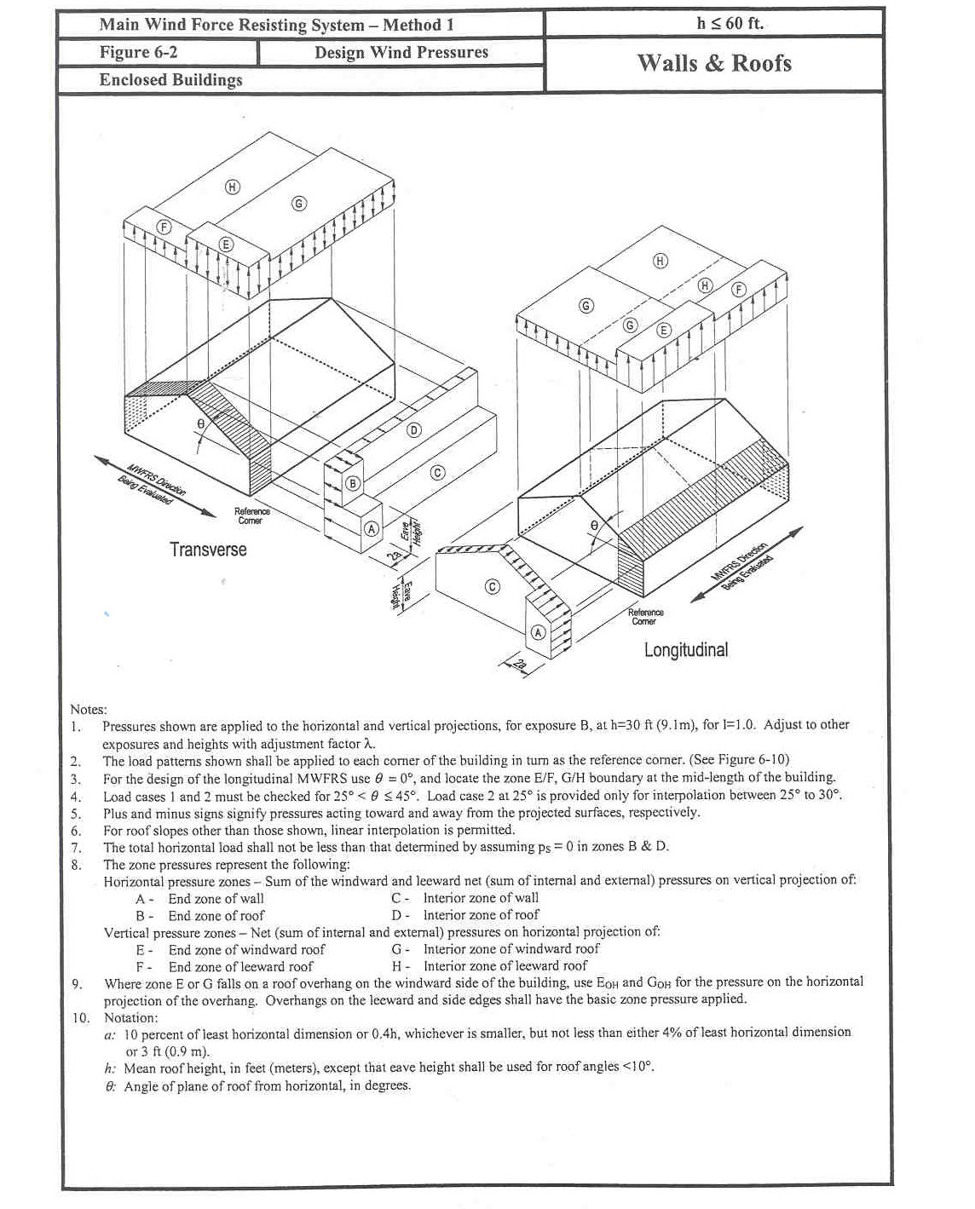

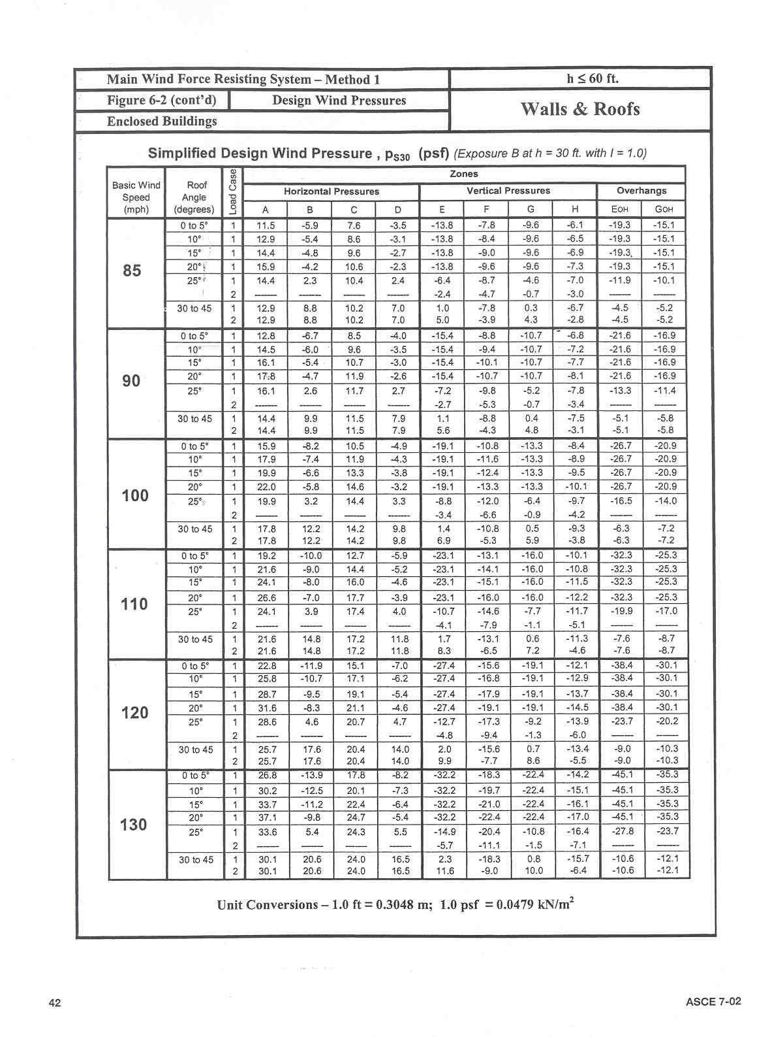
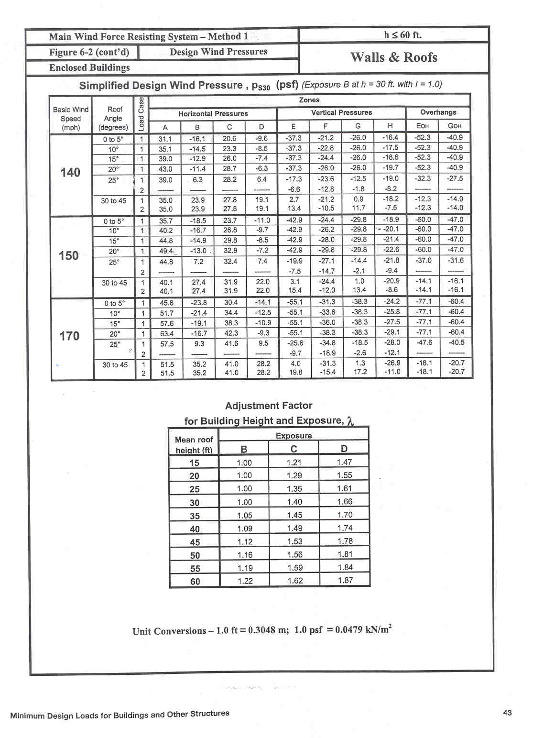

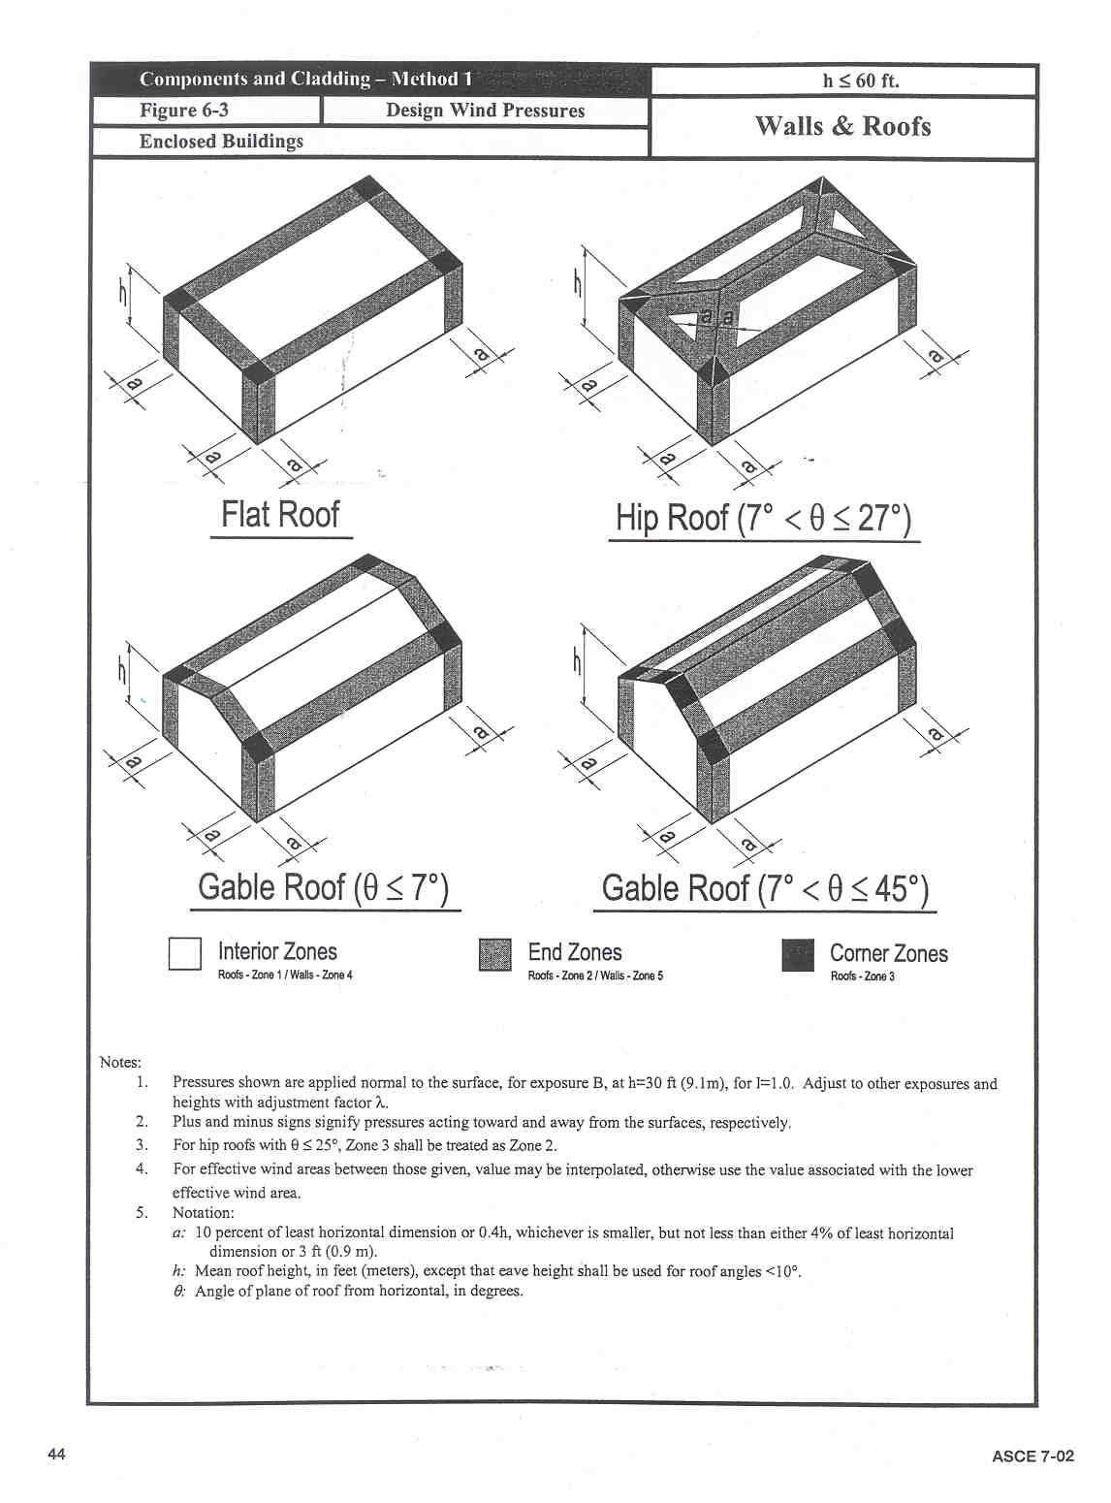
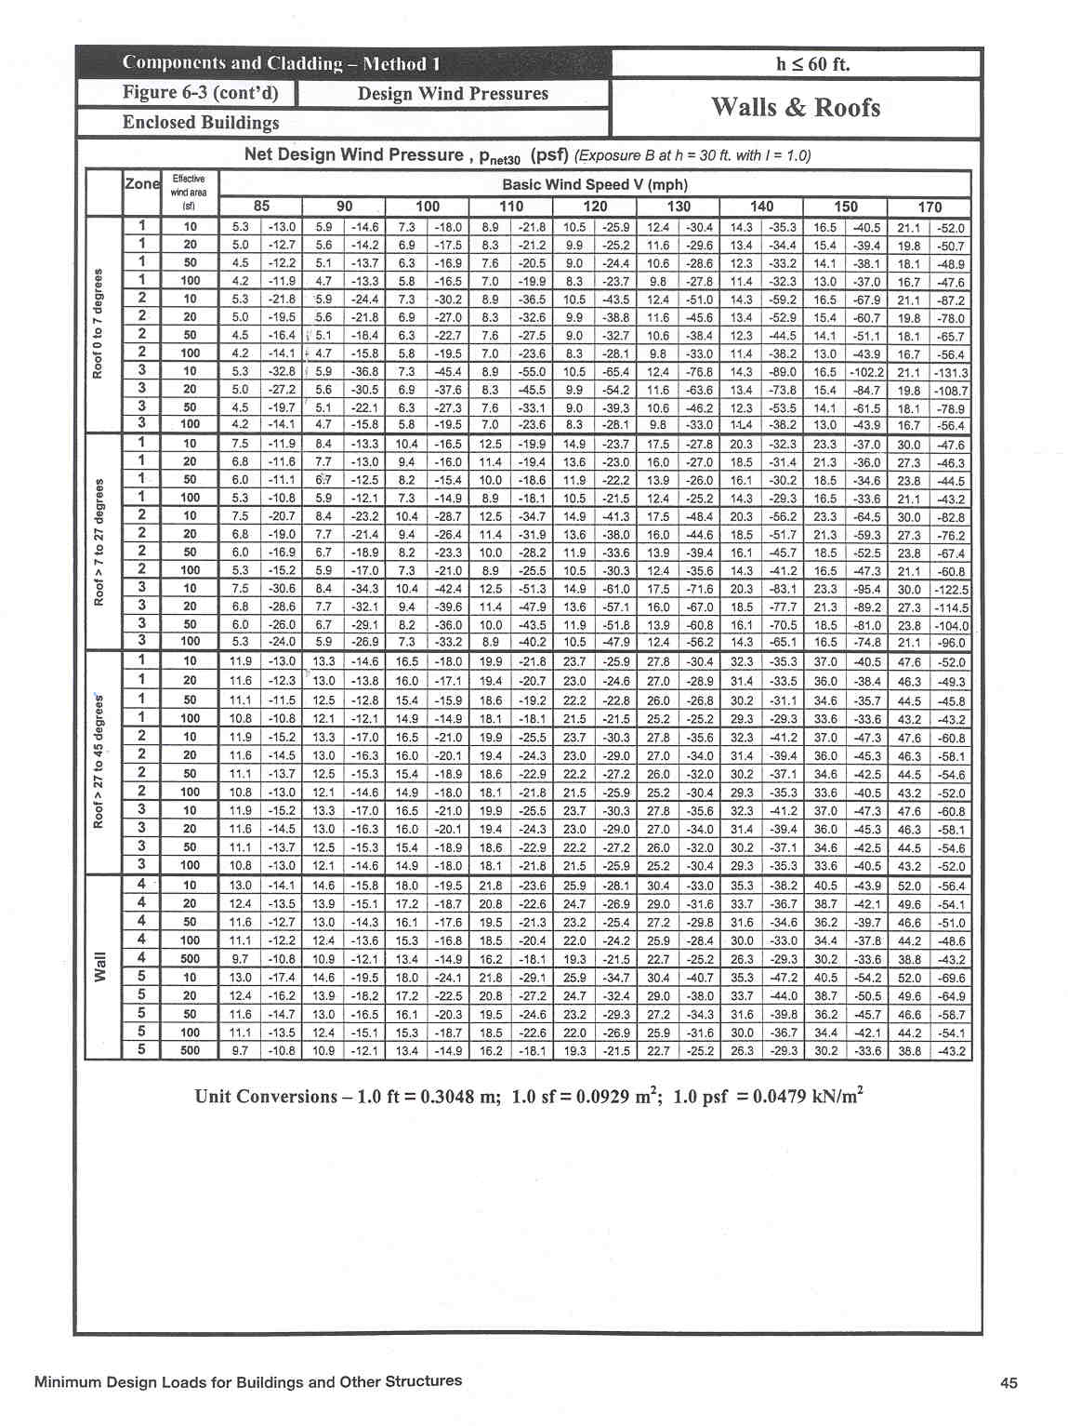

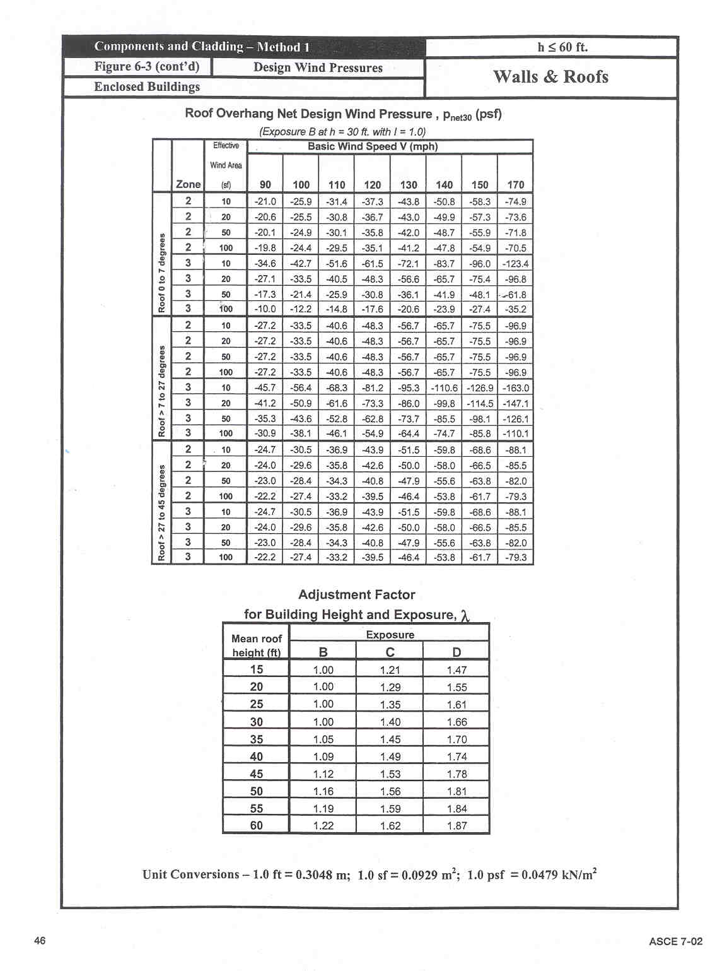

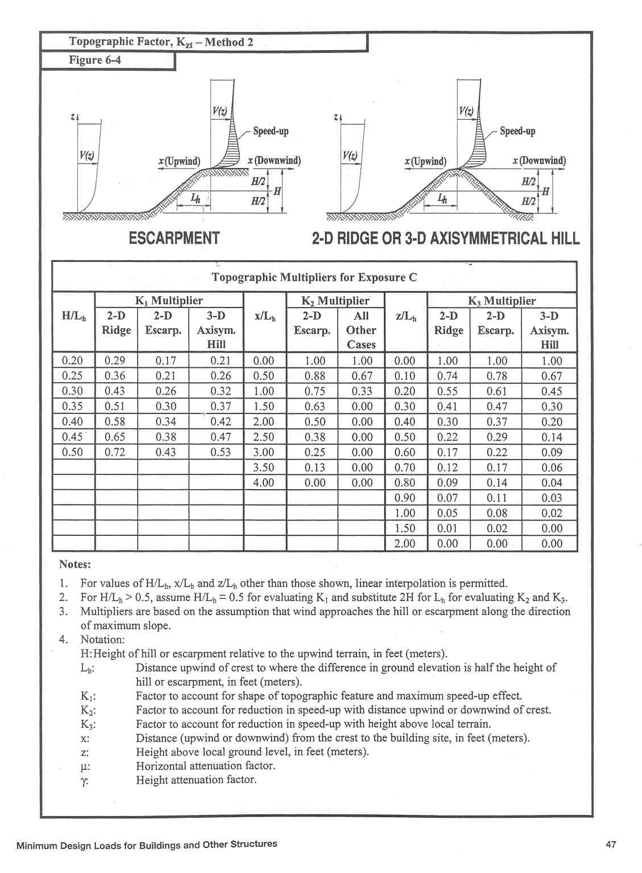

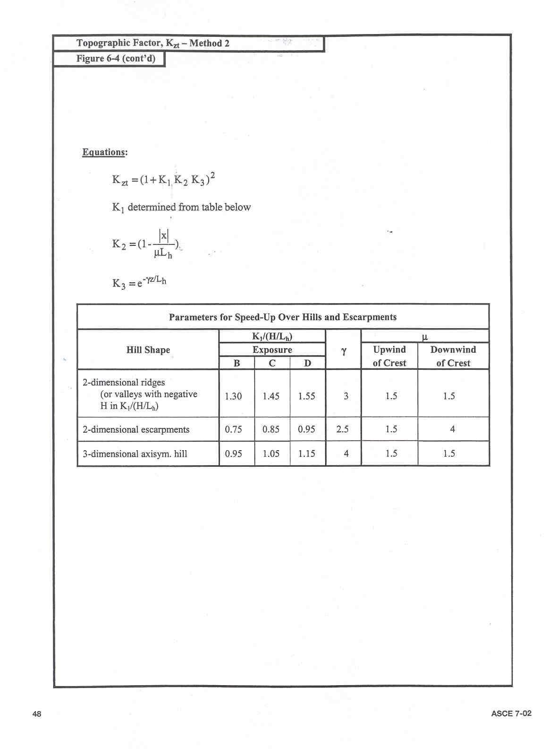

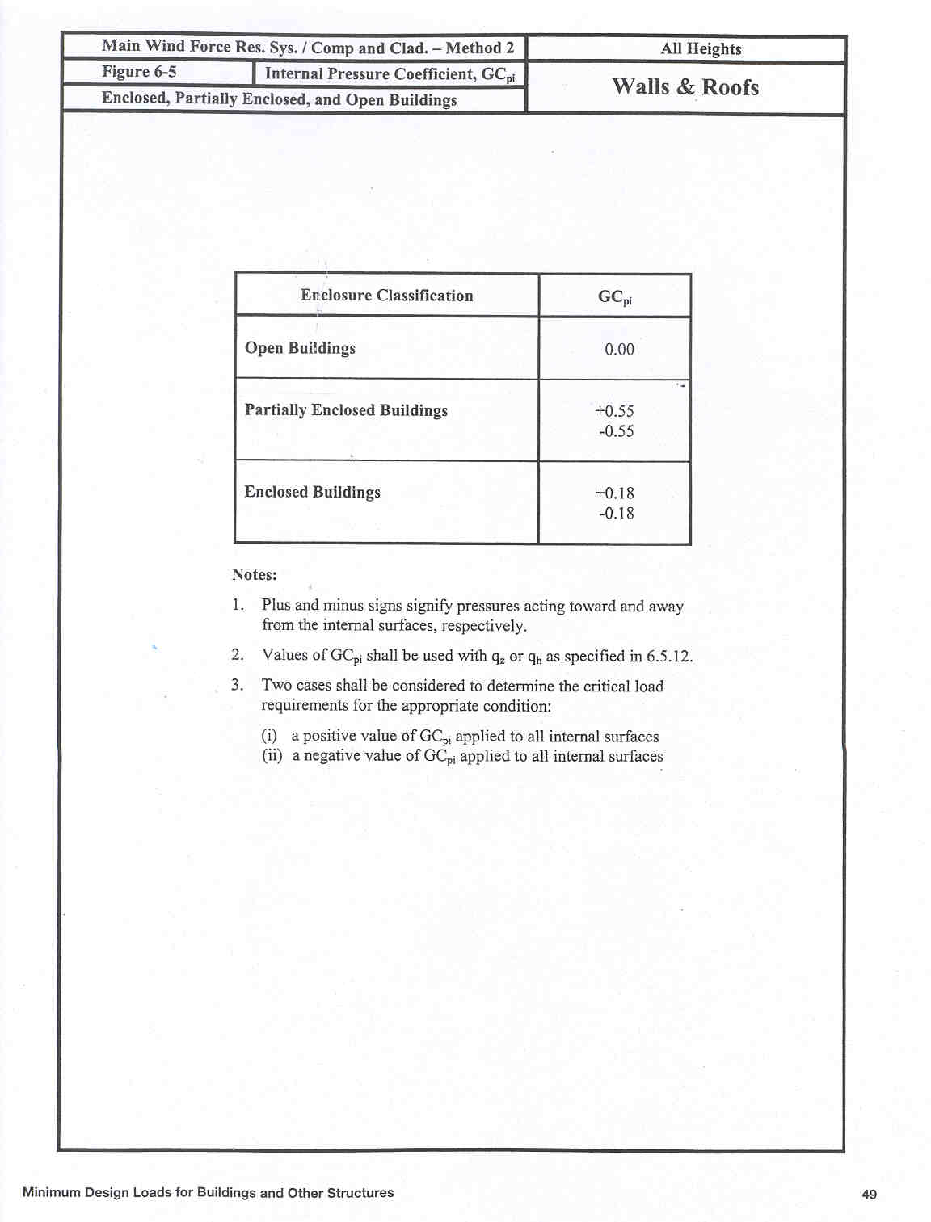
Note: Section 6.5.12 of ASCE 7-02 corresponds to the section 4.2.24 of this Model Code
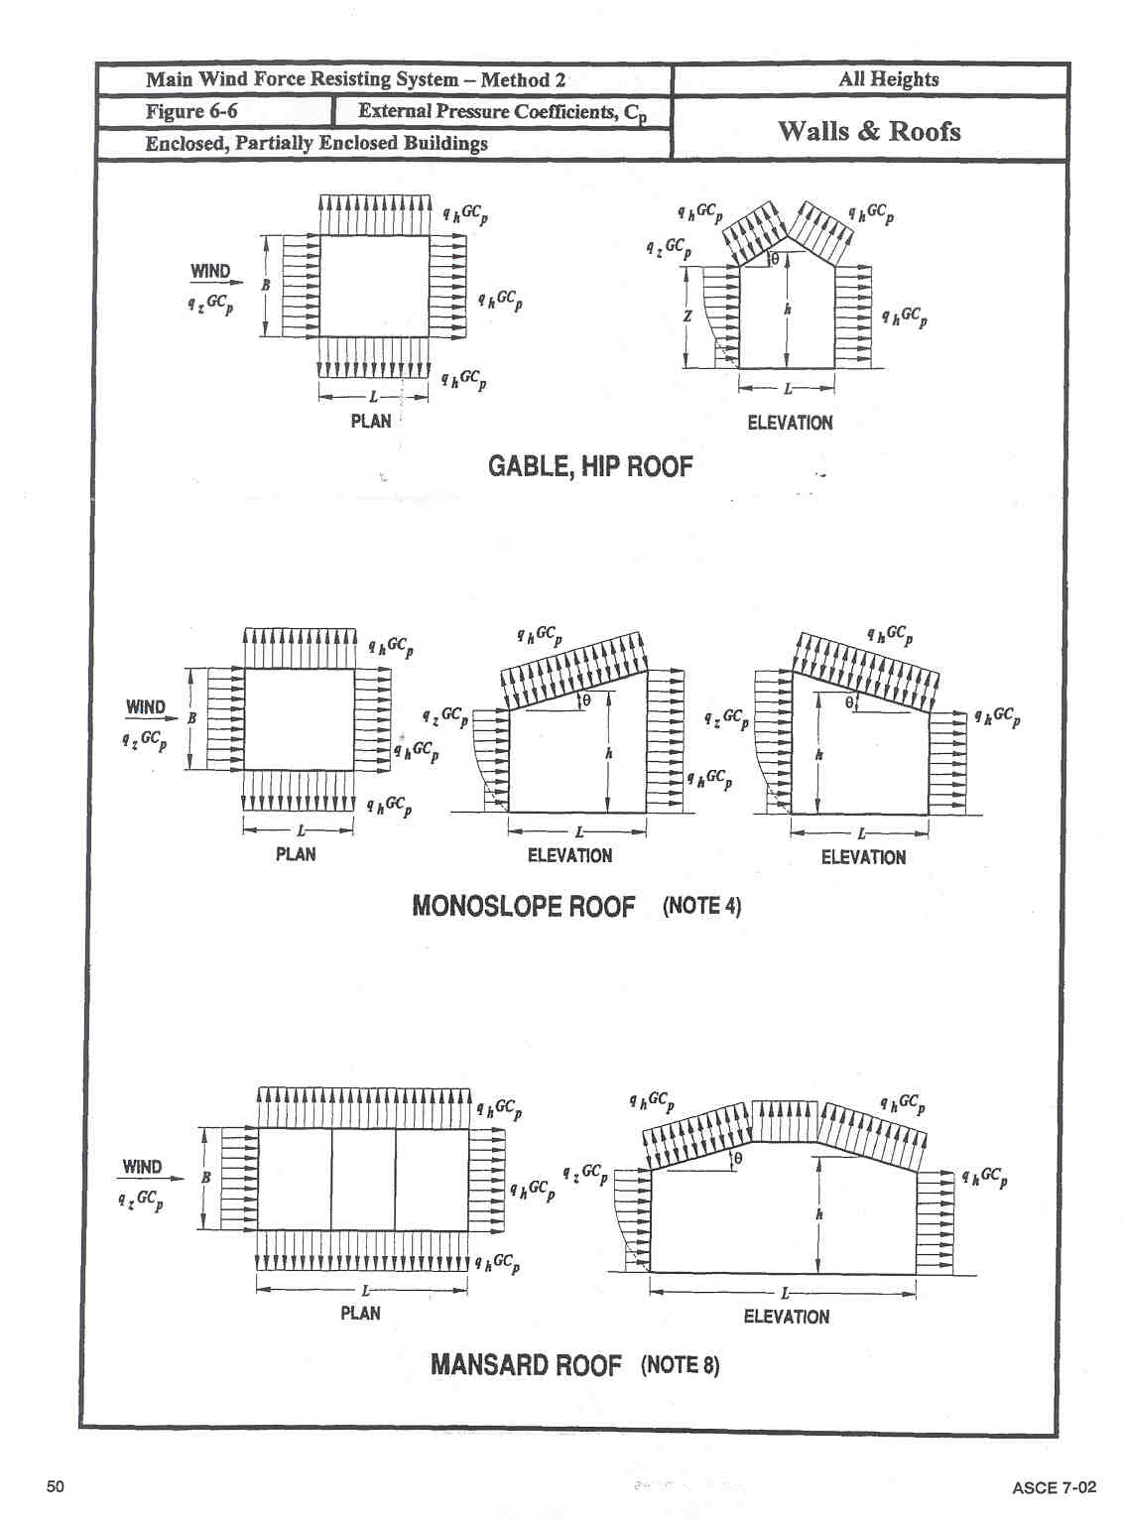

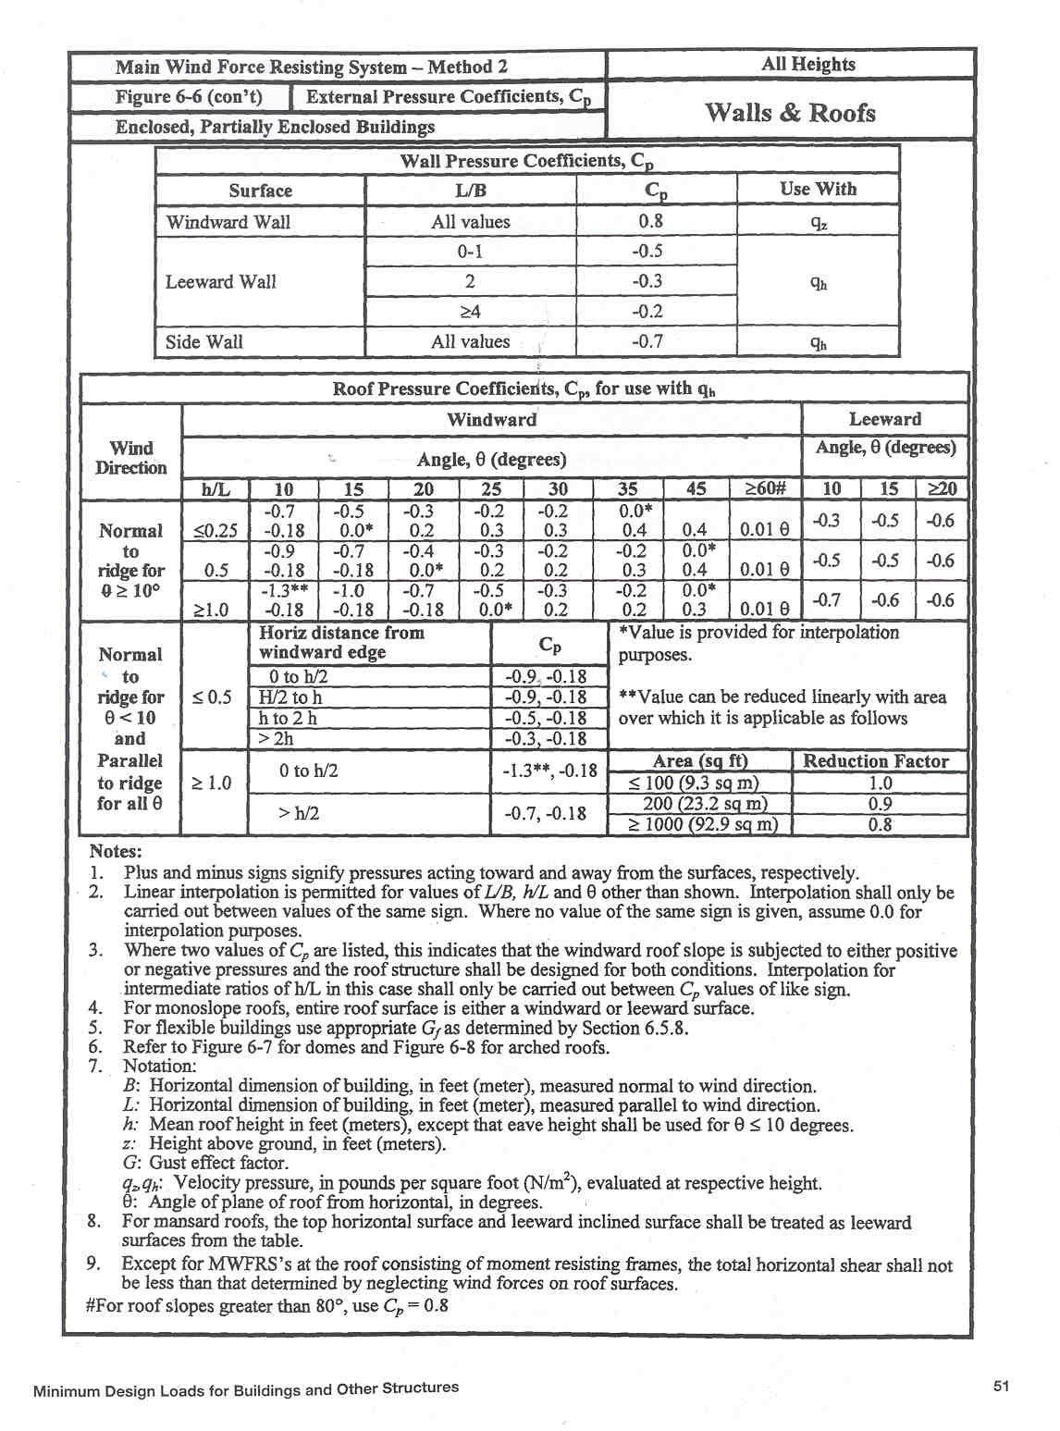
Note: Section 6.5.8 of ASCE 7-02 corresponds to the section 4.2.20 of this Model Code
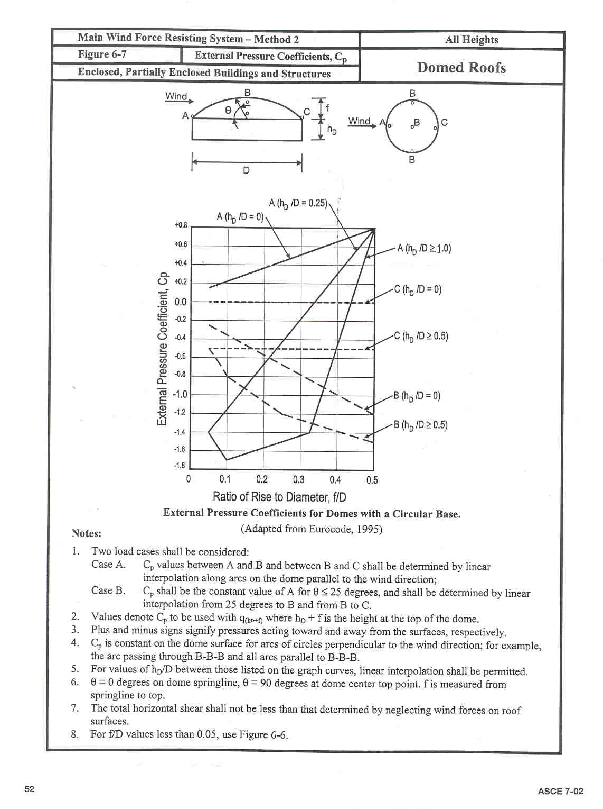
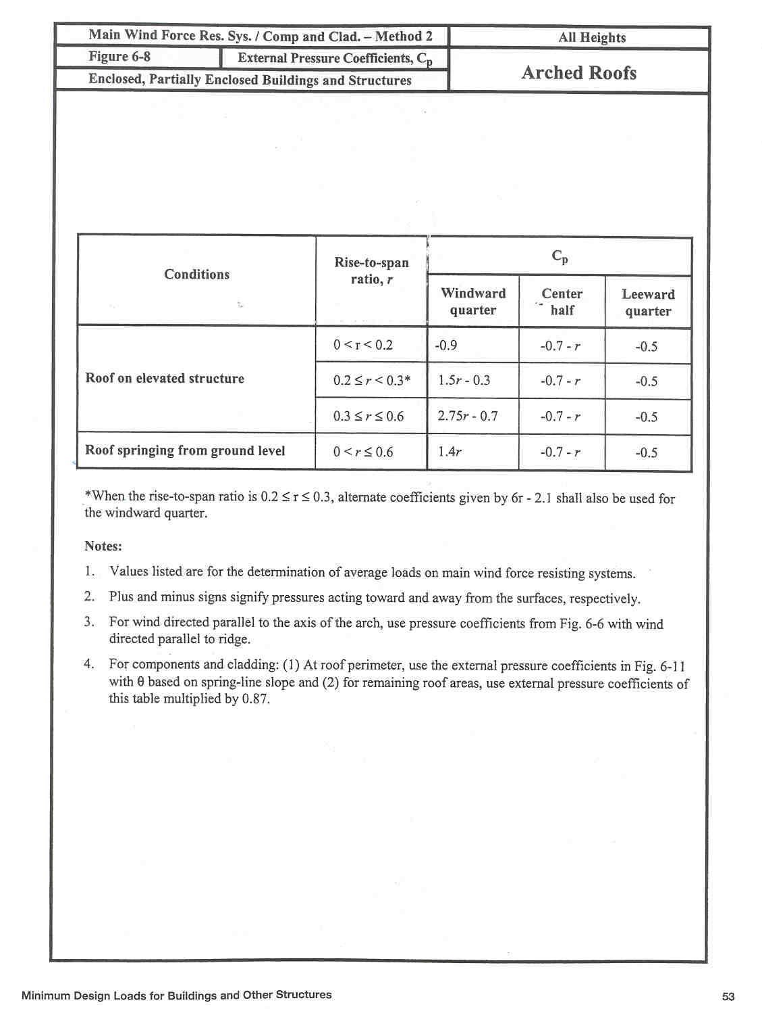

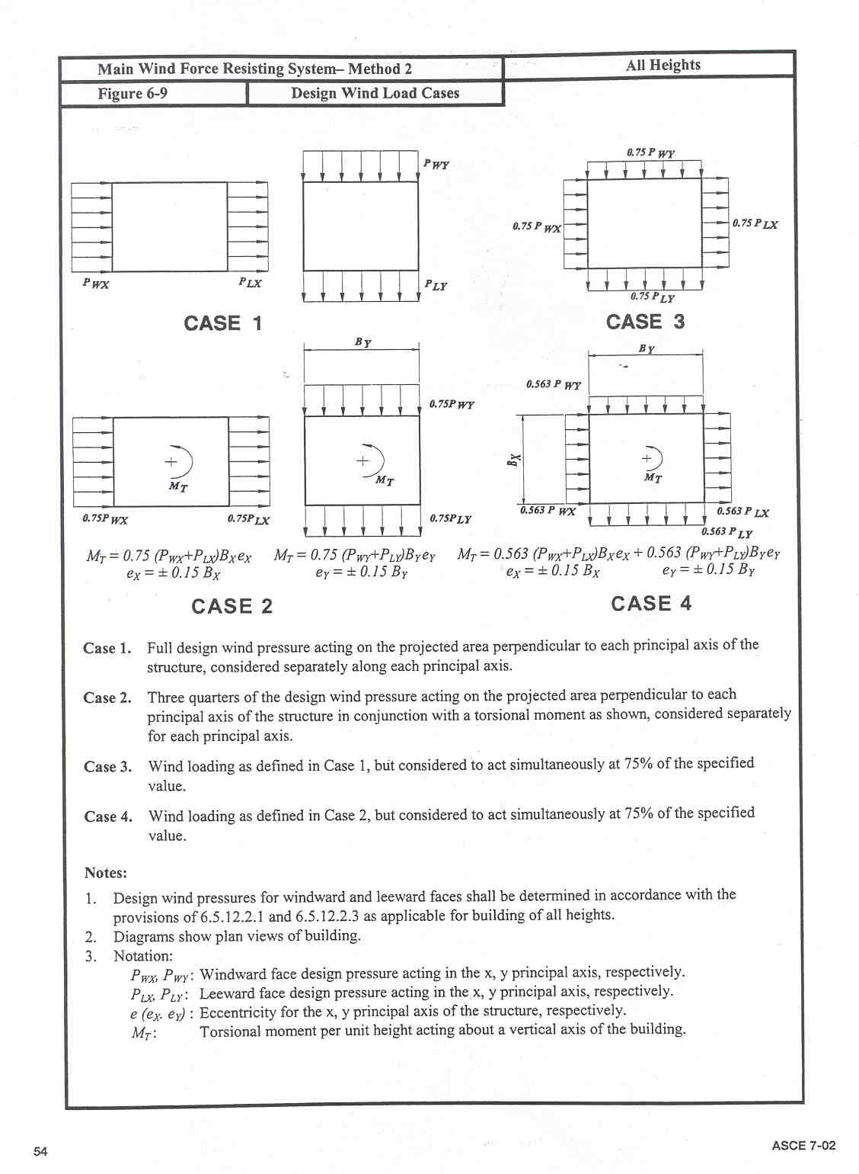
Note: Sections 6.5.12.2.1 and 6.5.12.2.3 of ASCE 7-02 correspond respectively to the sections 4.2.24.2.1 and 4.2.24.2.3 of this Model Code

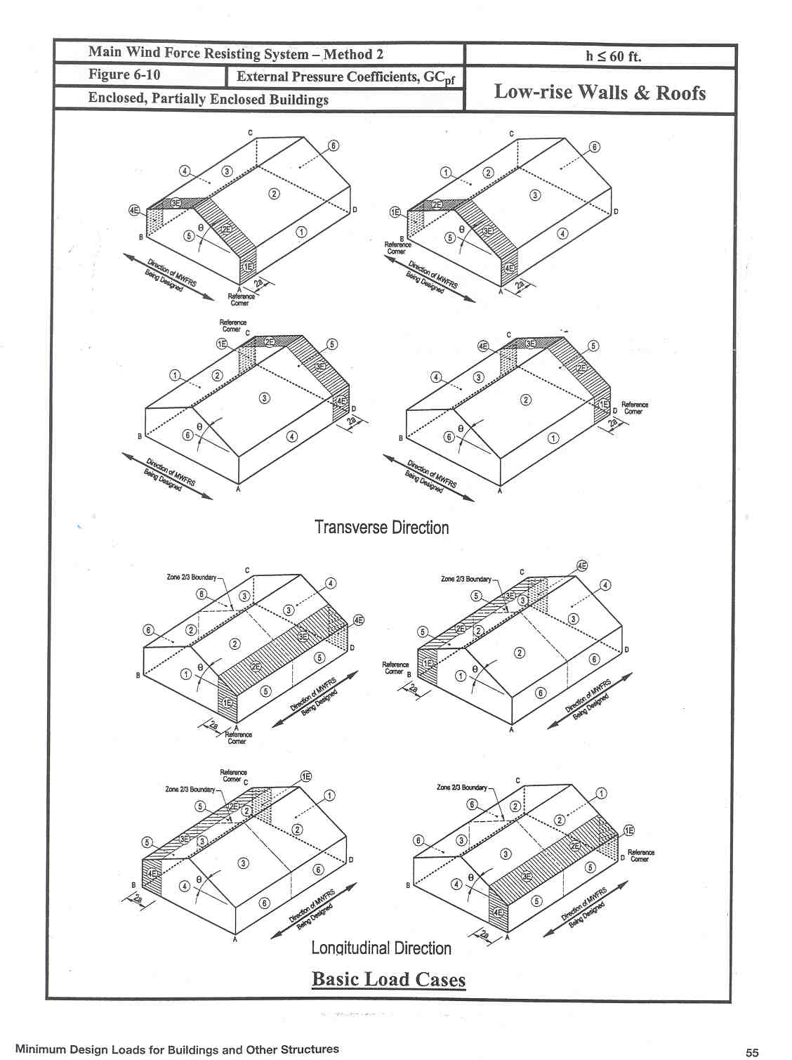
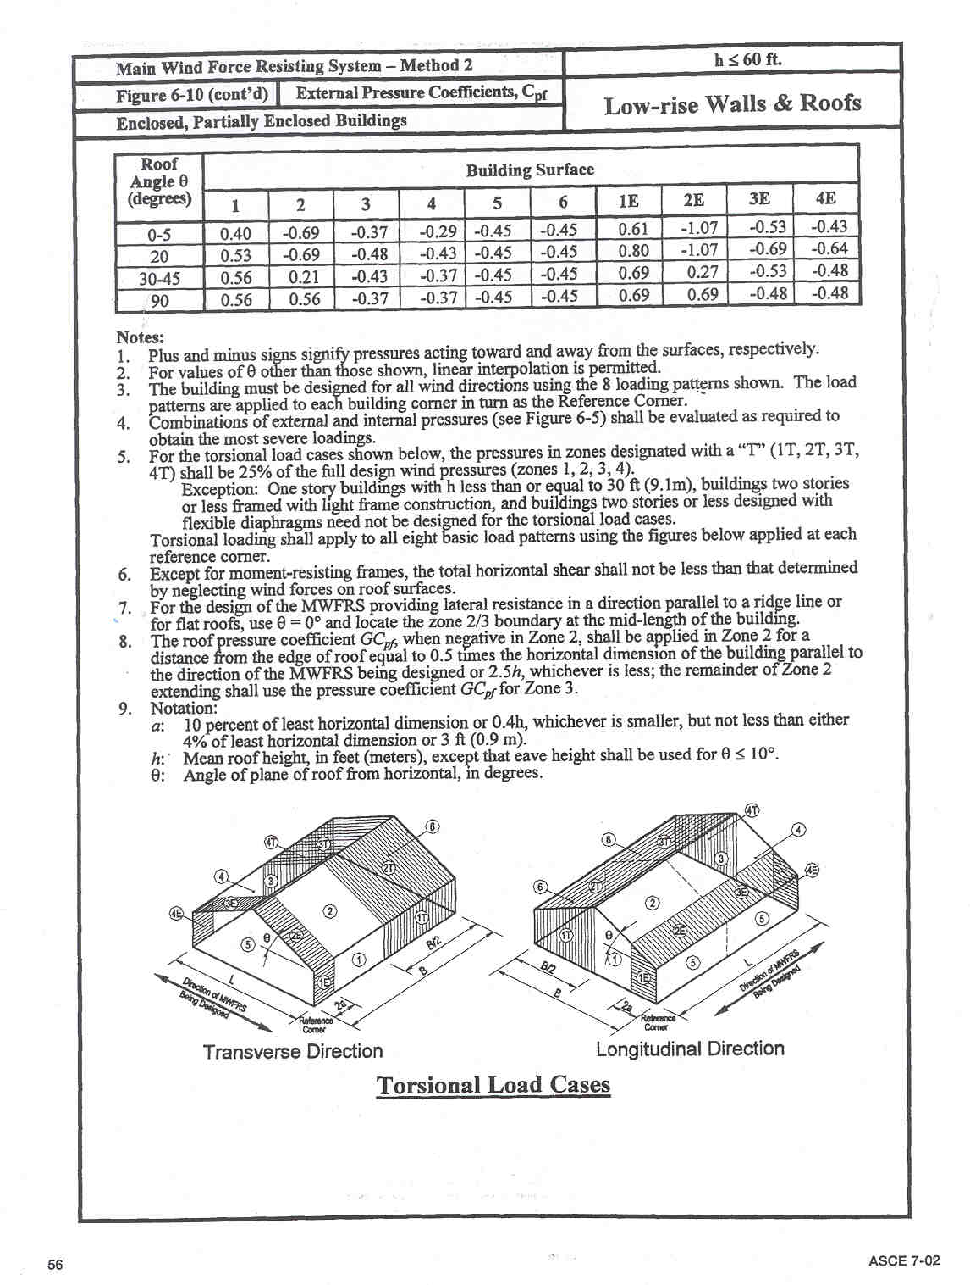
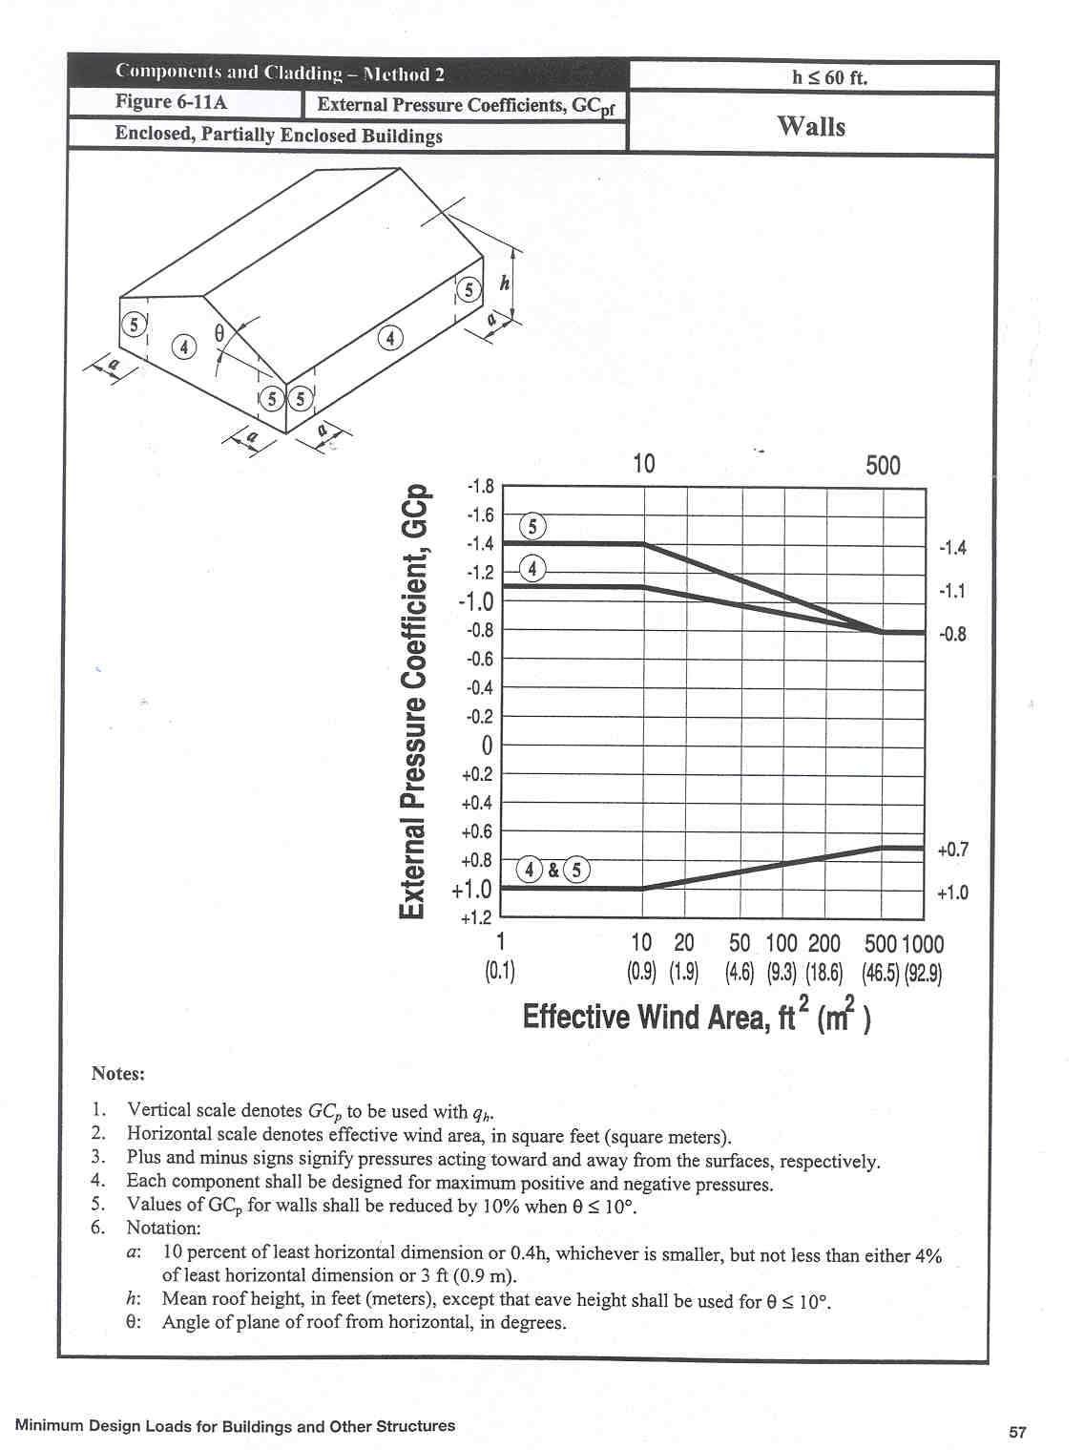
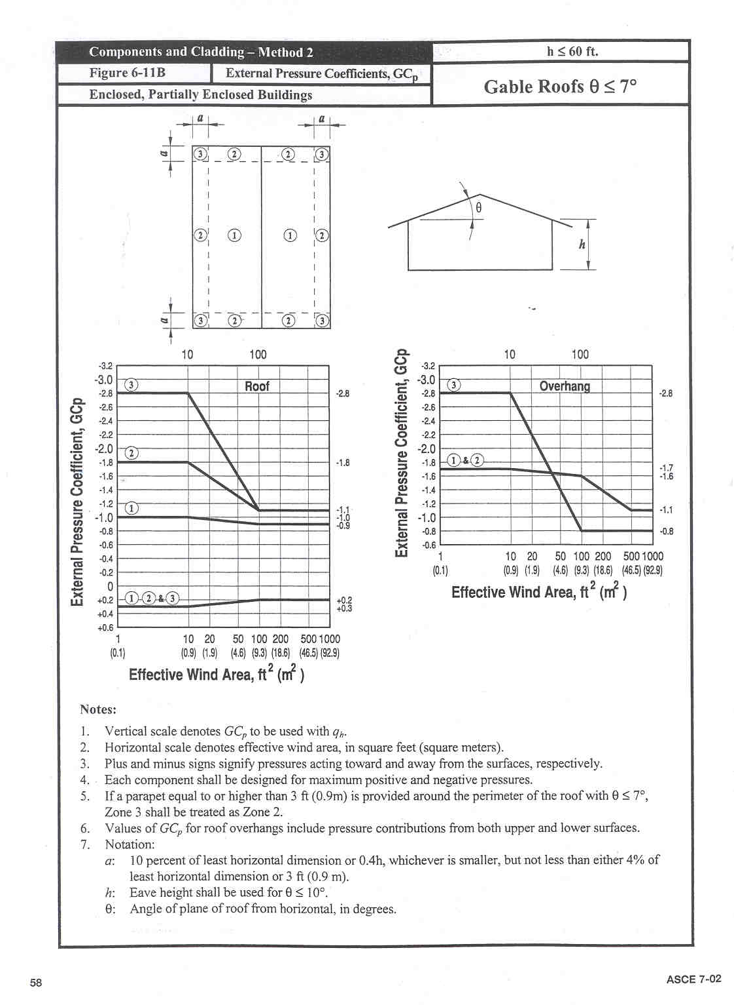
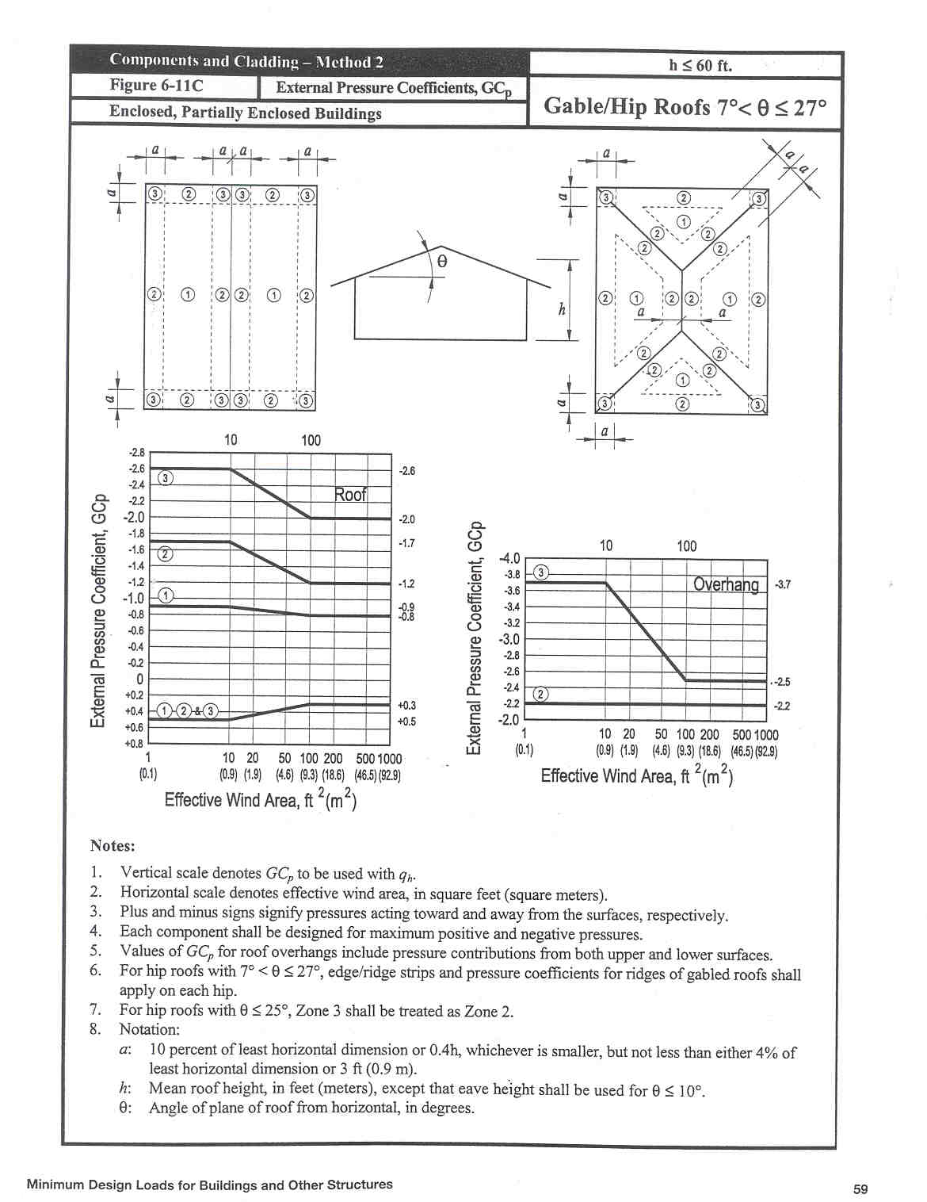
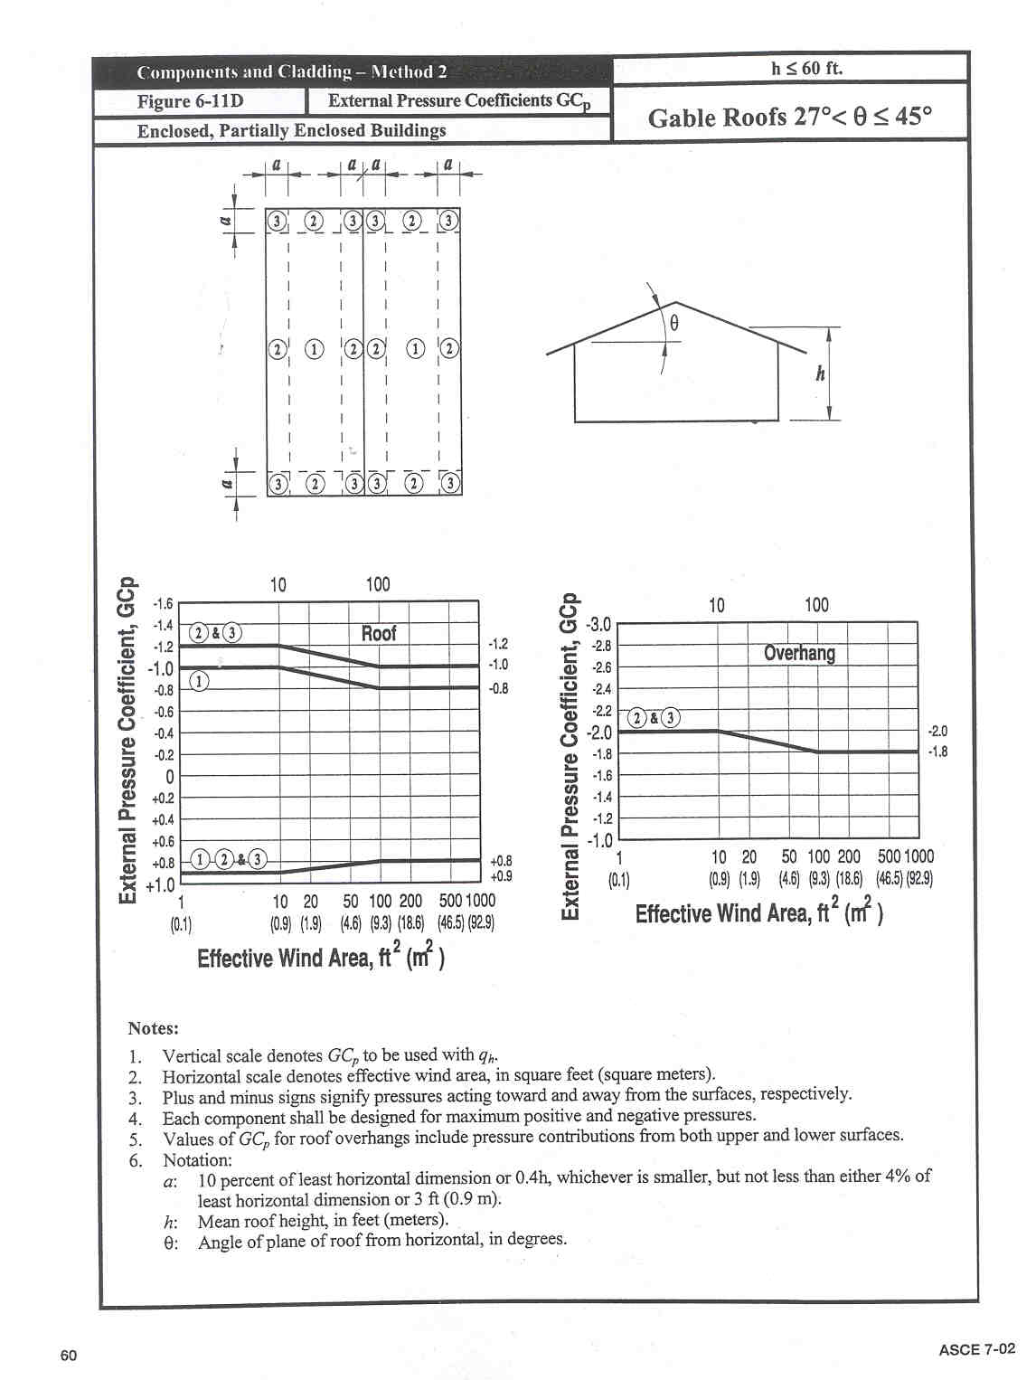
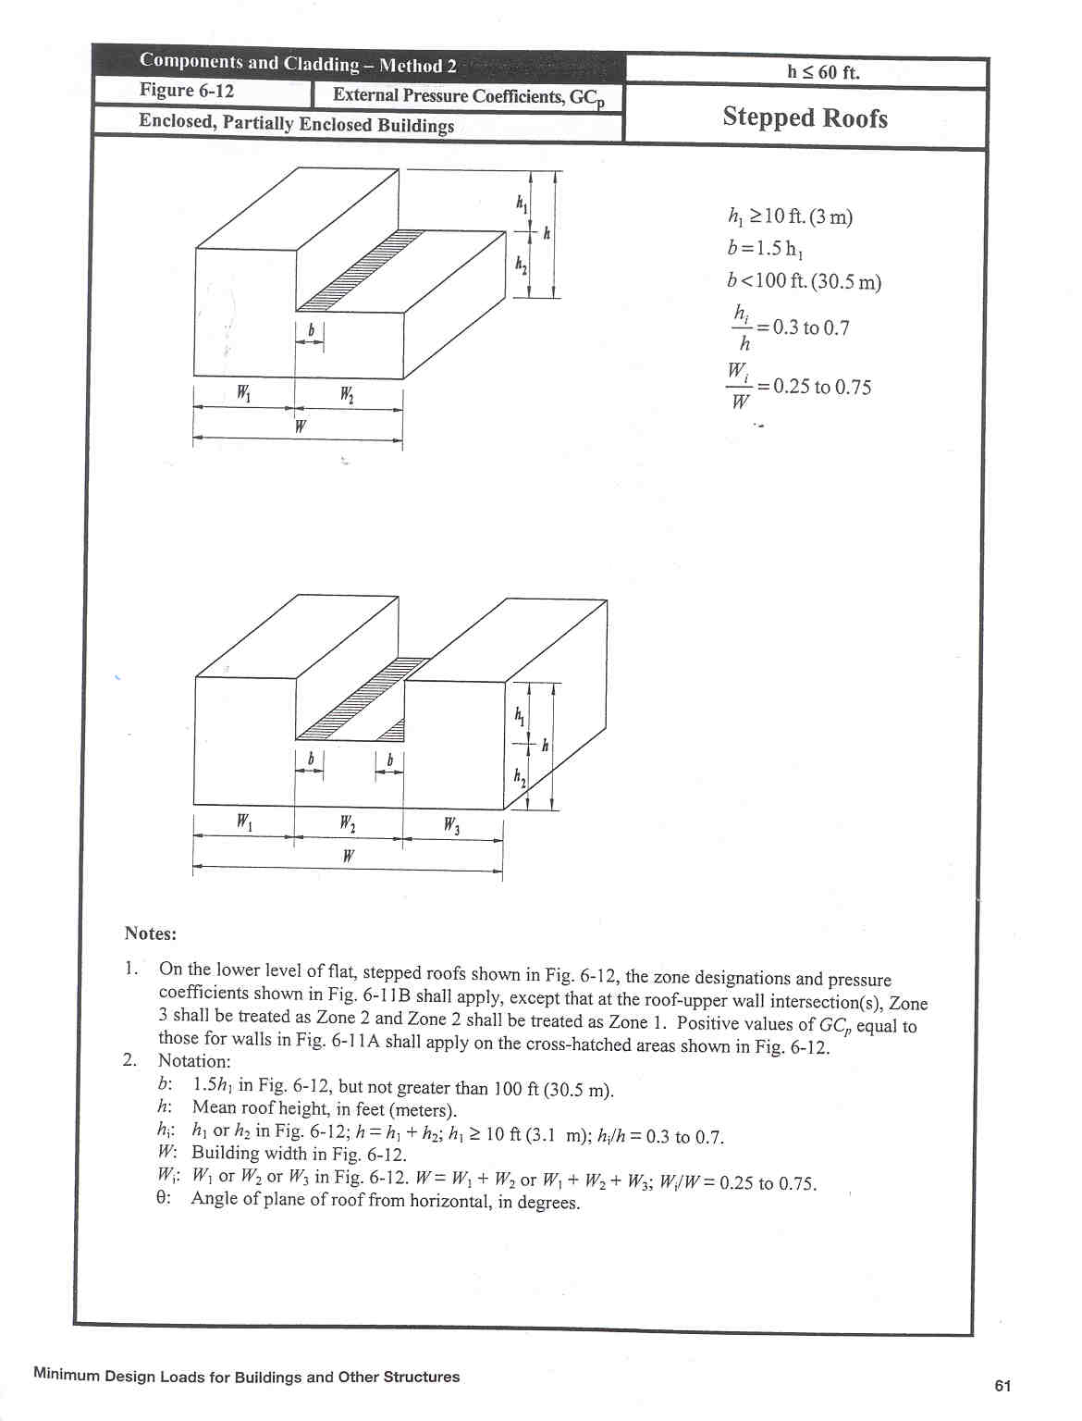
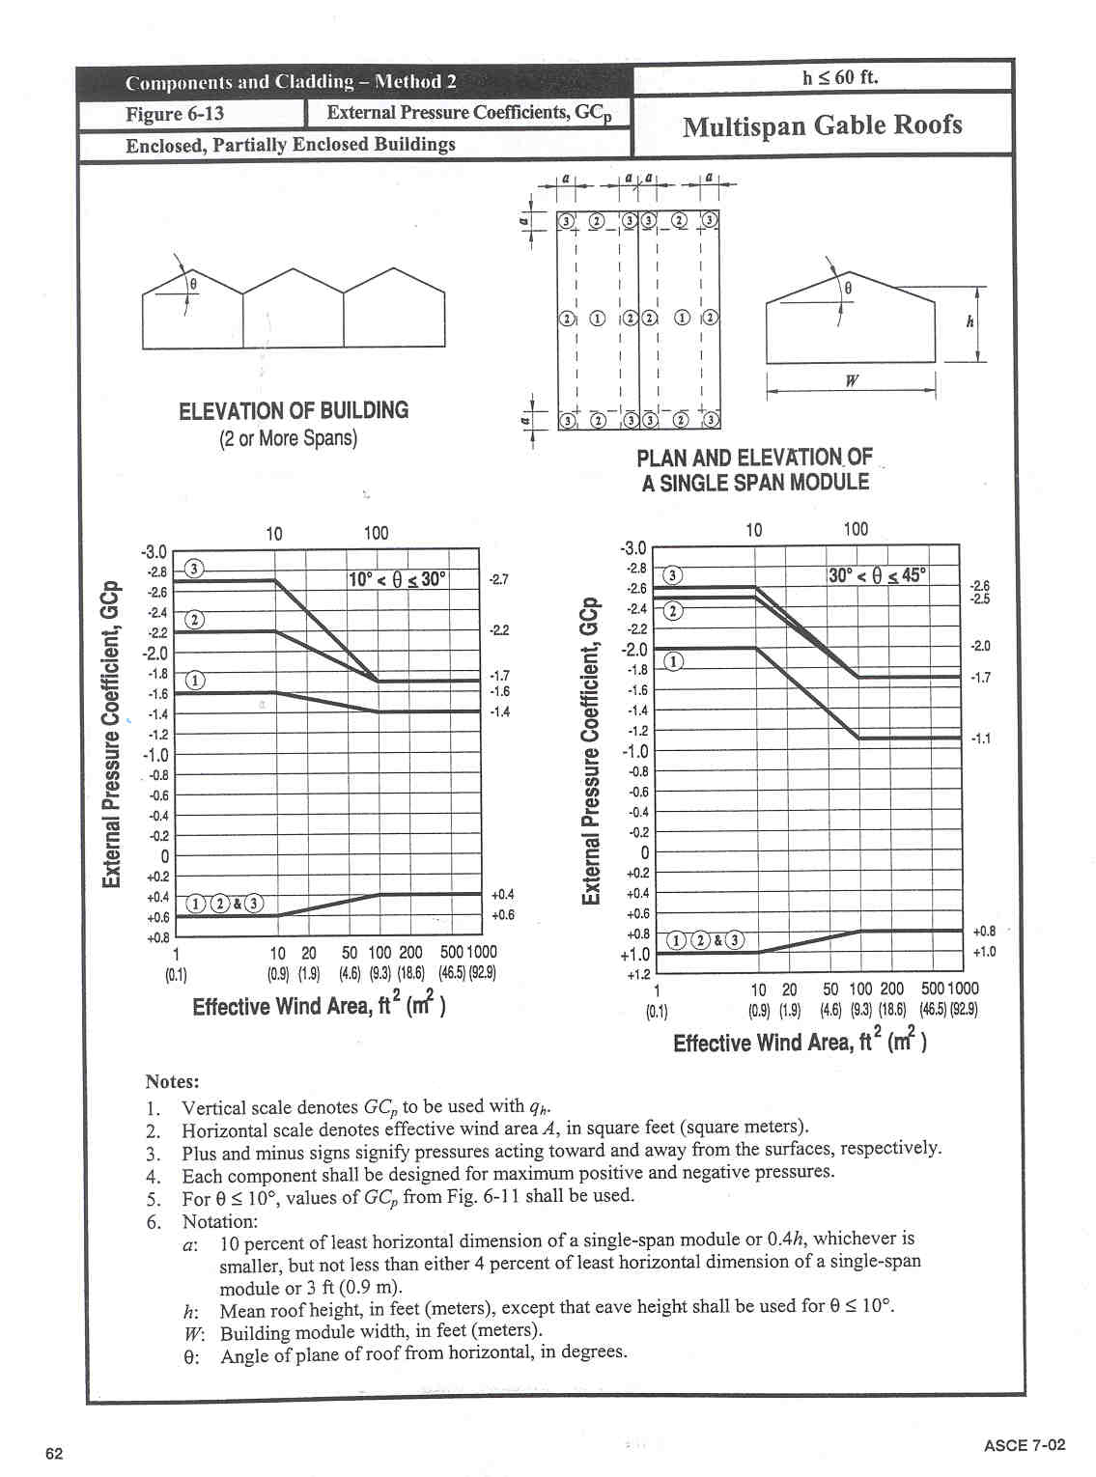
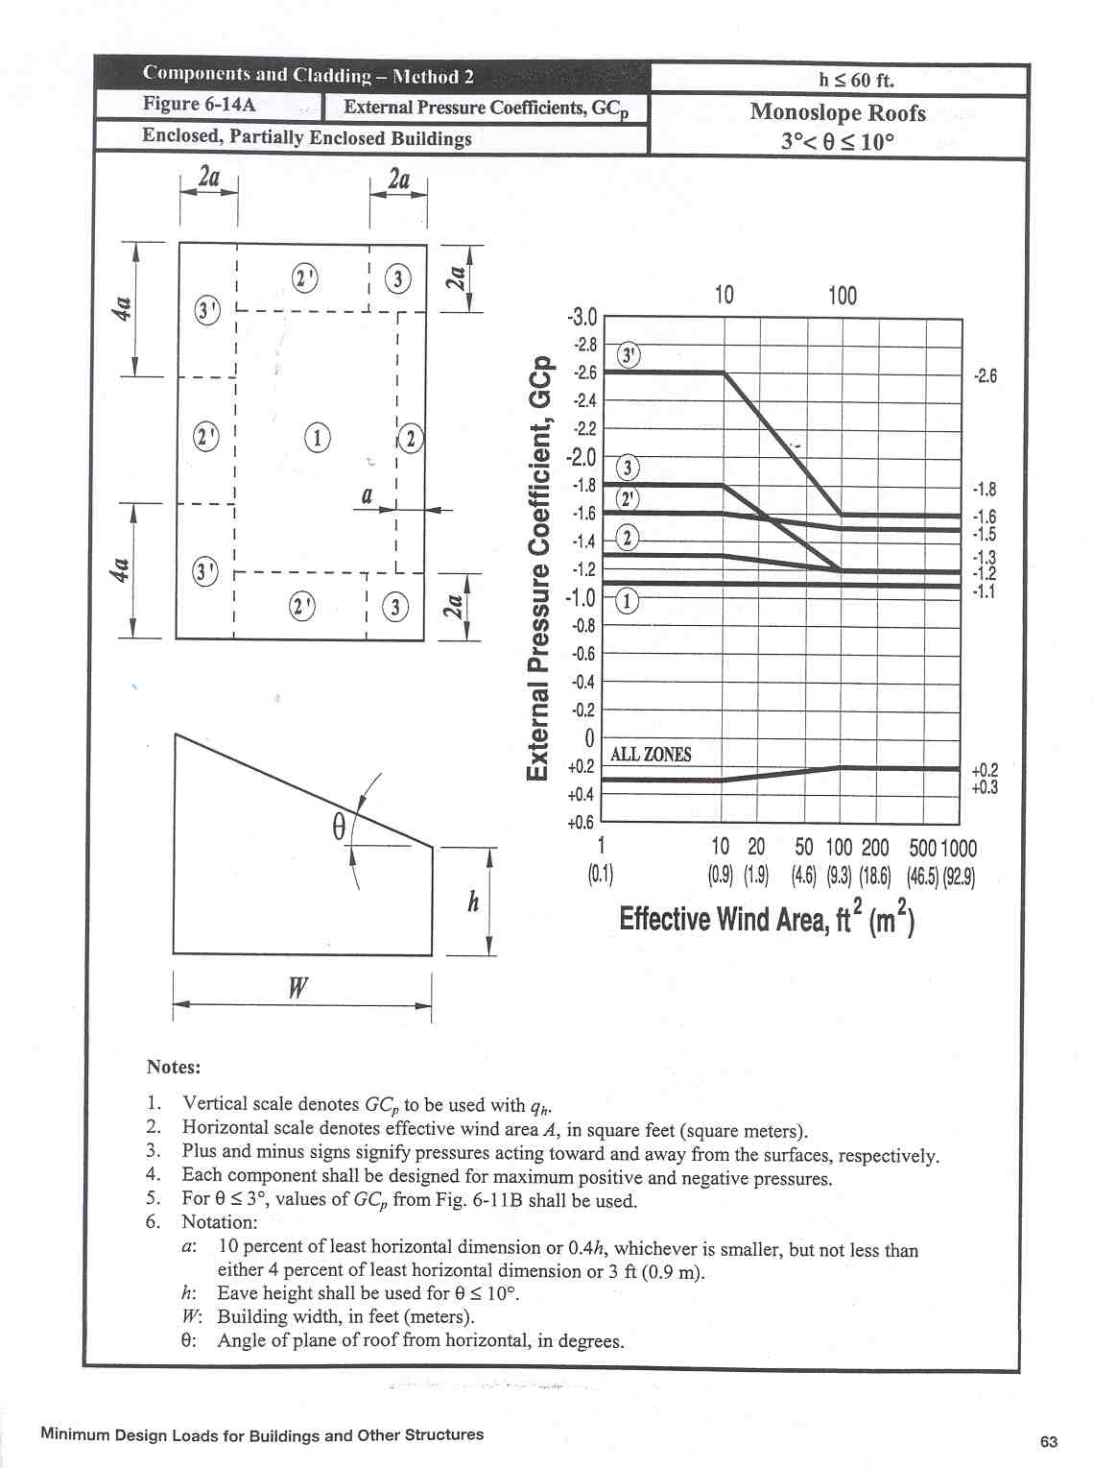

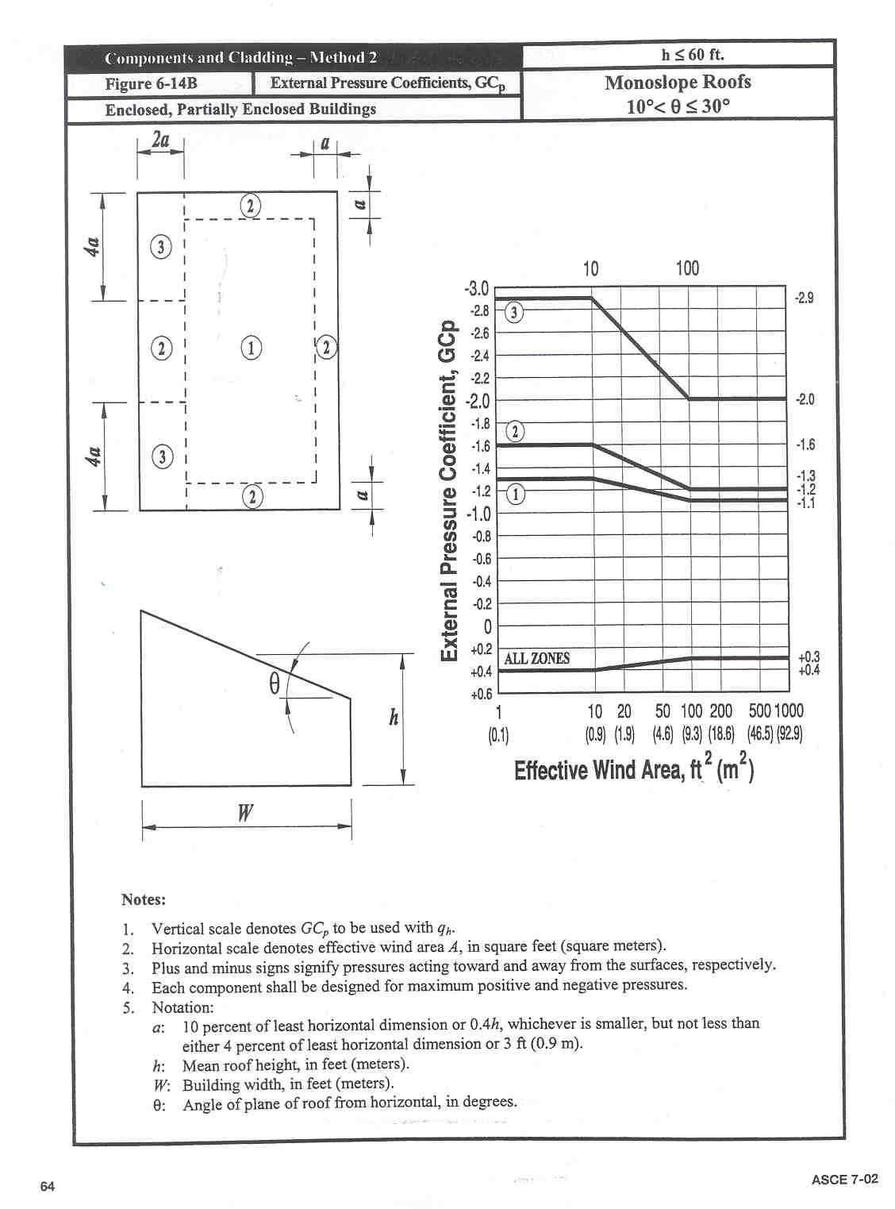
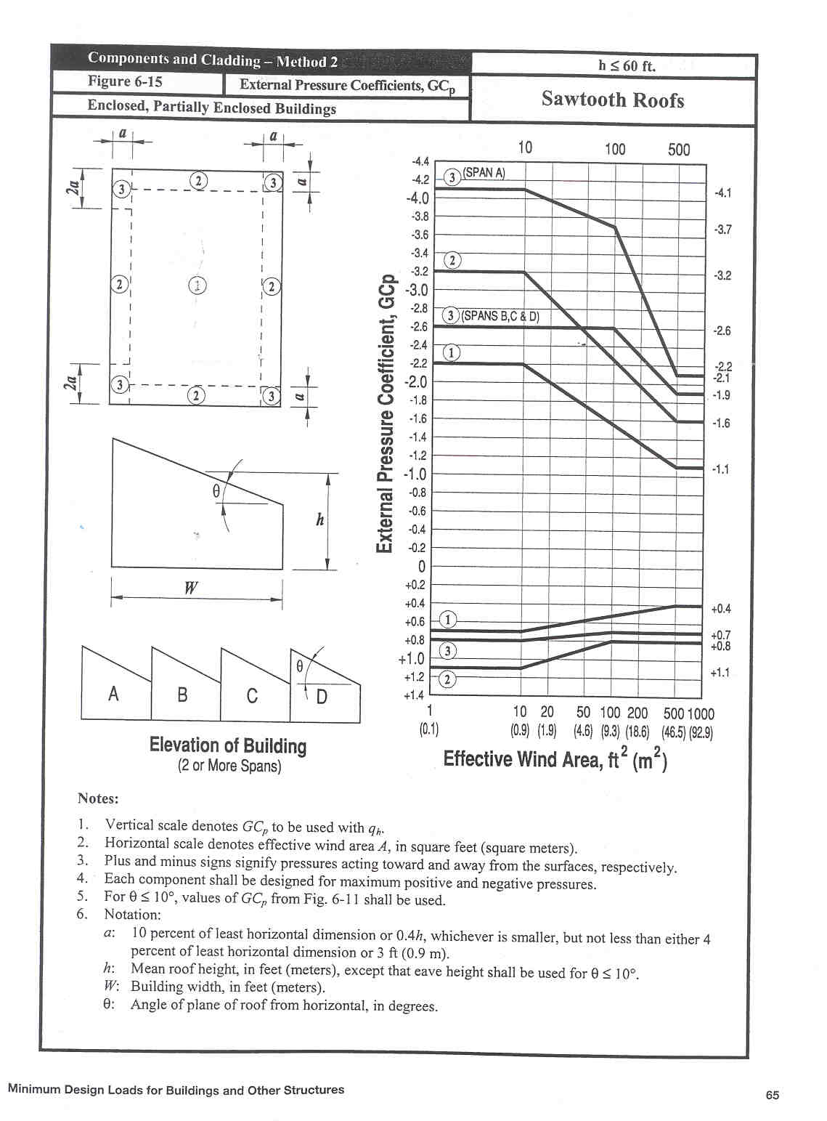
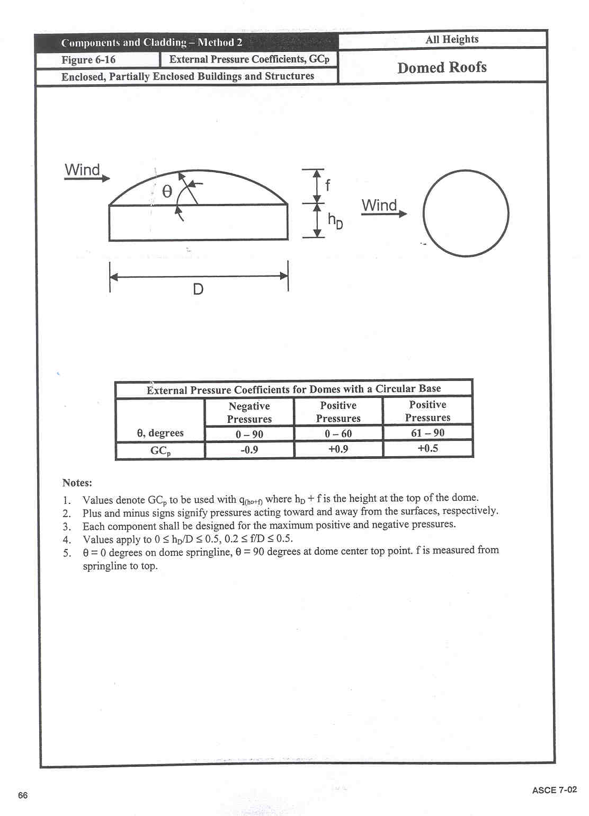

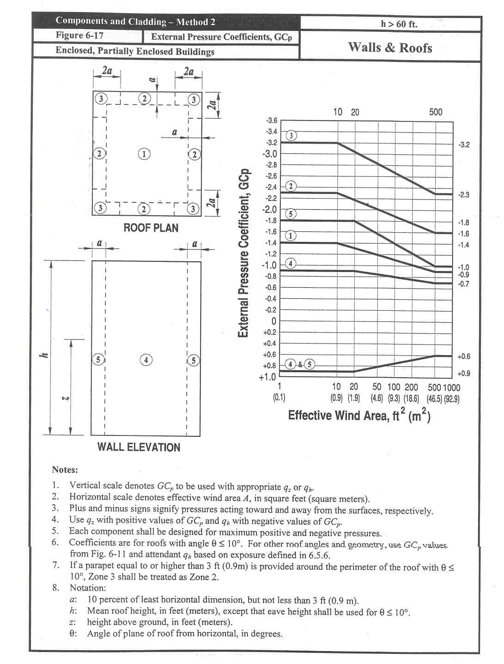
Note: Section 6.5.6 of ASCE 7-02 corresponds to the section 4.2.12 of this Model Code
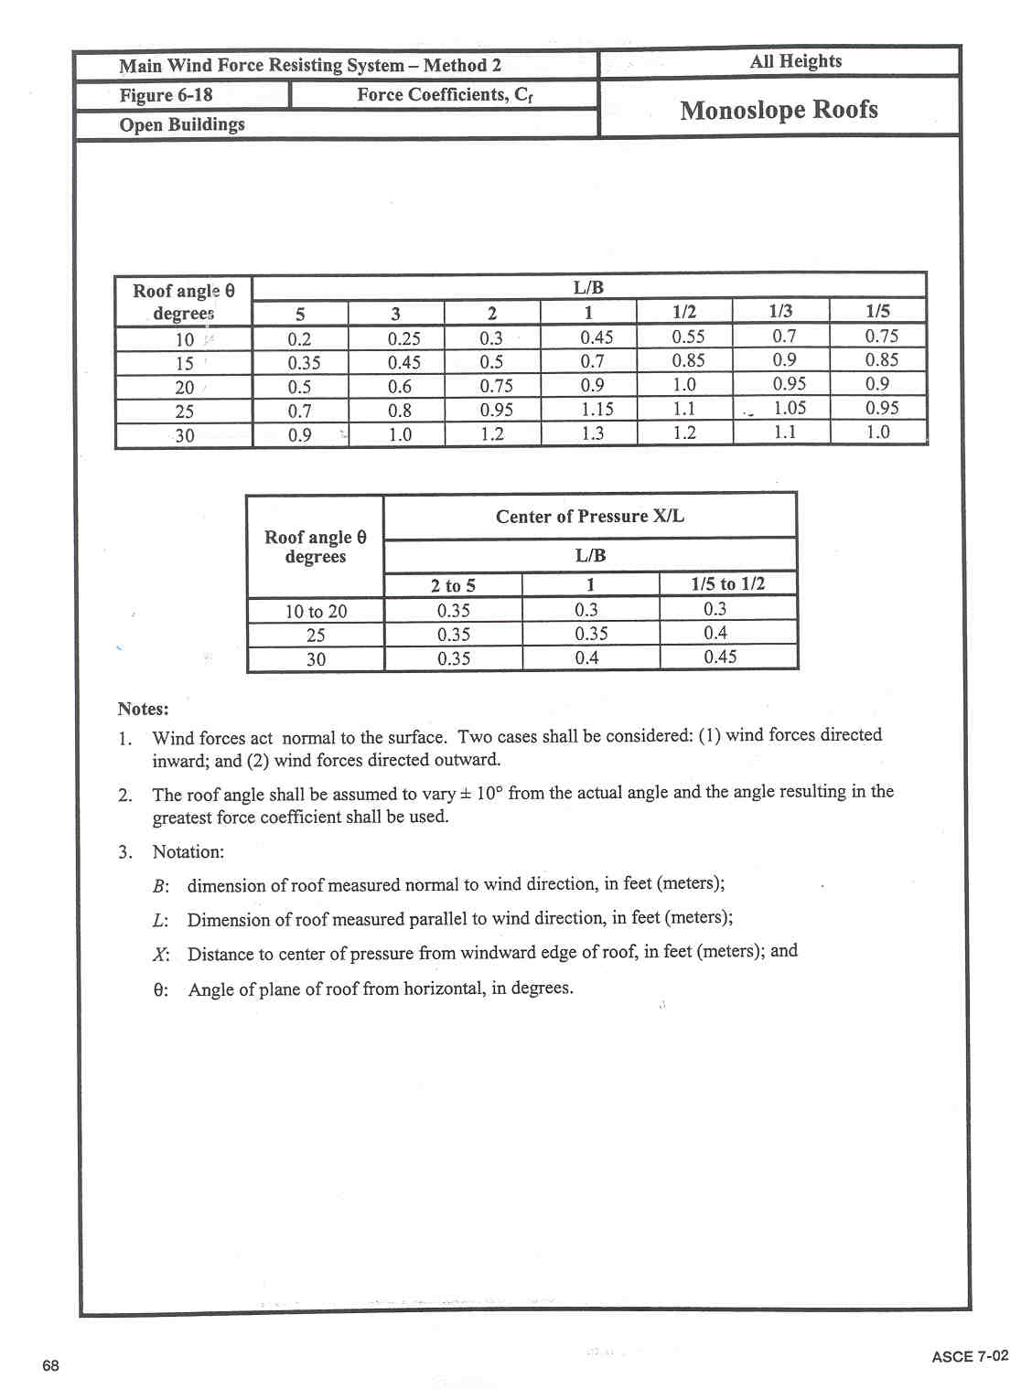
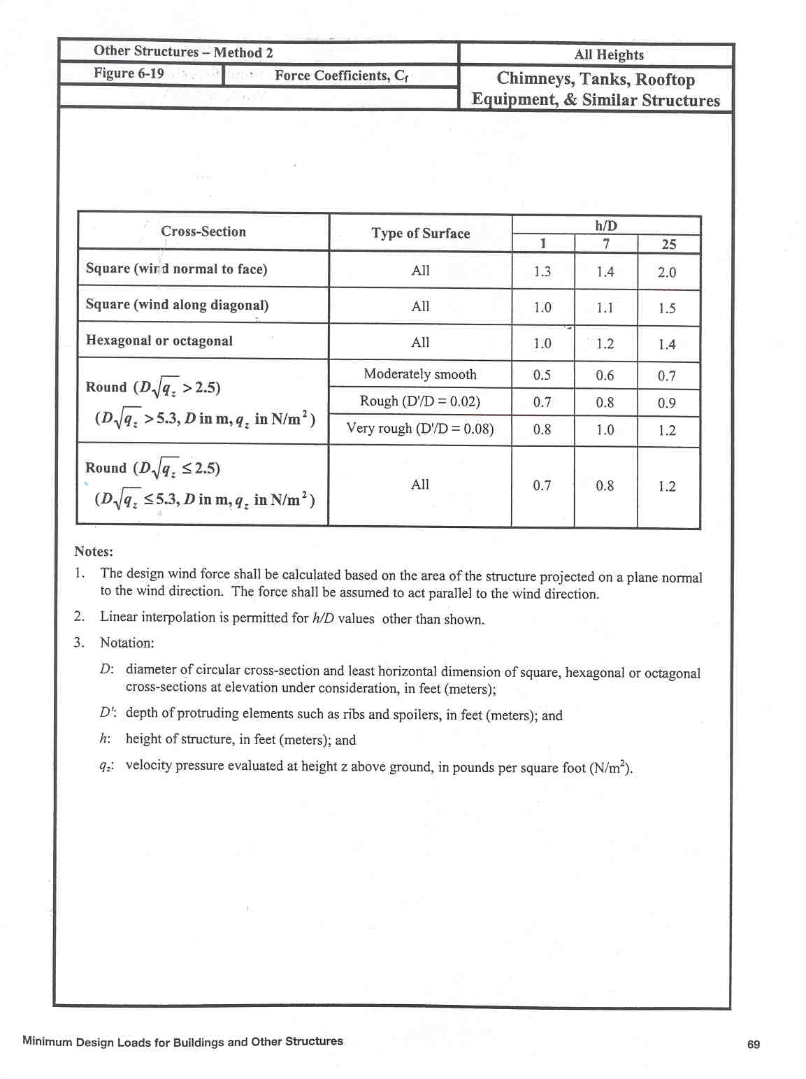

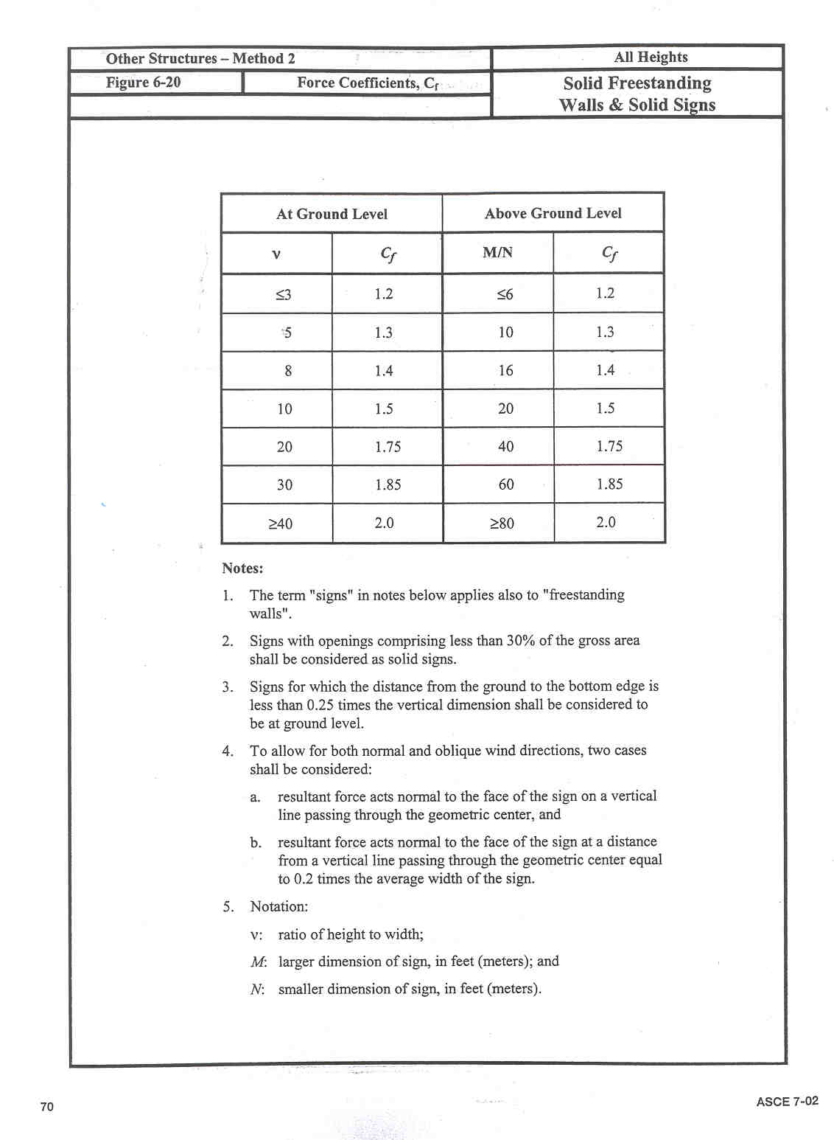

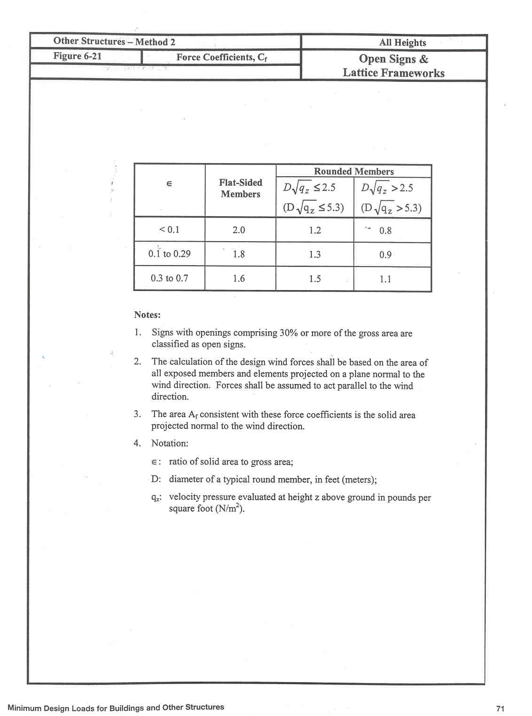

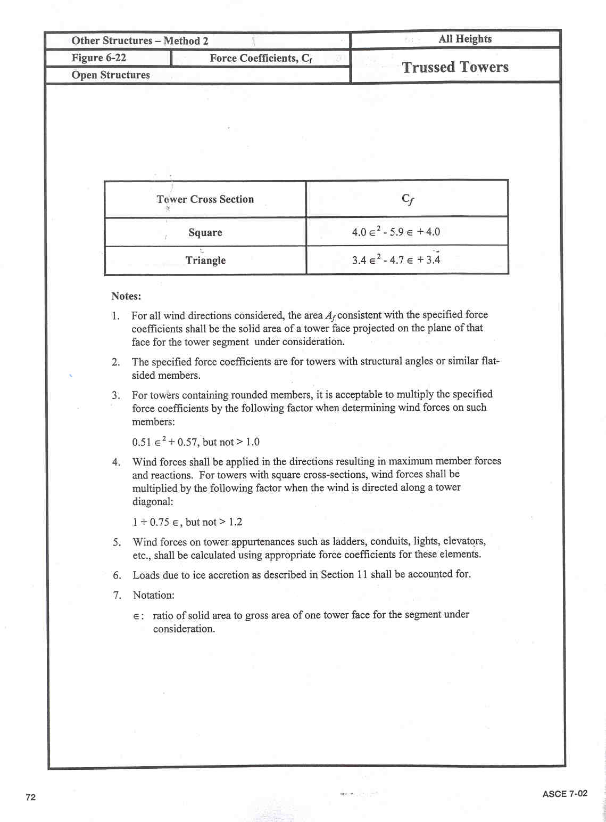

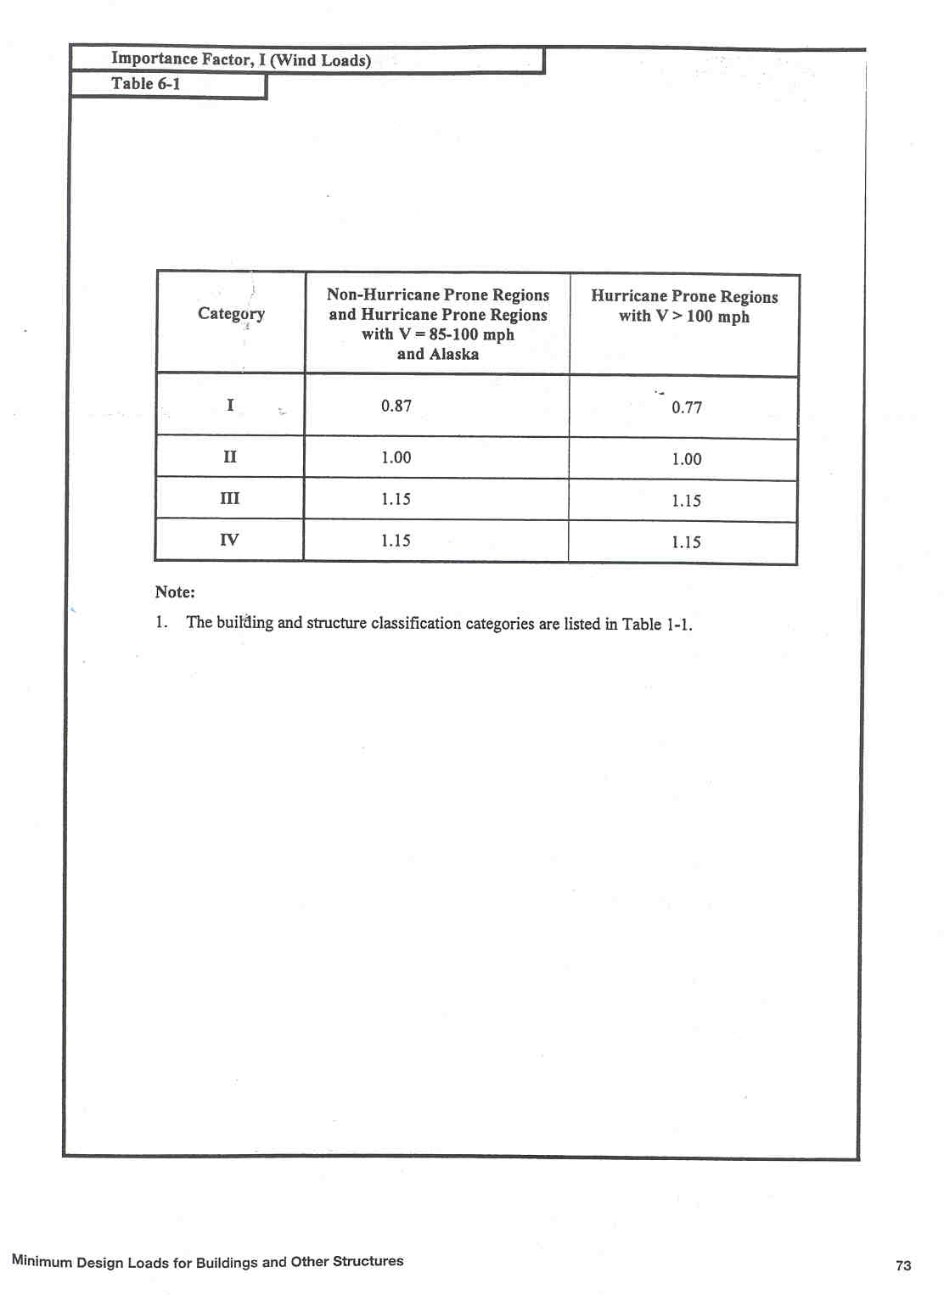
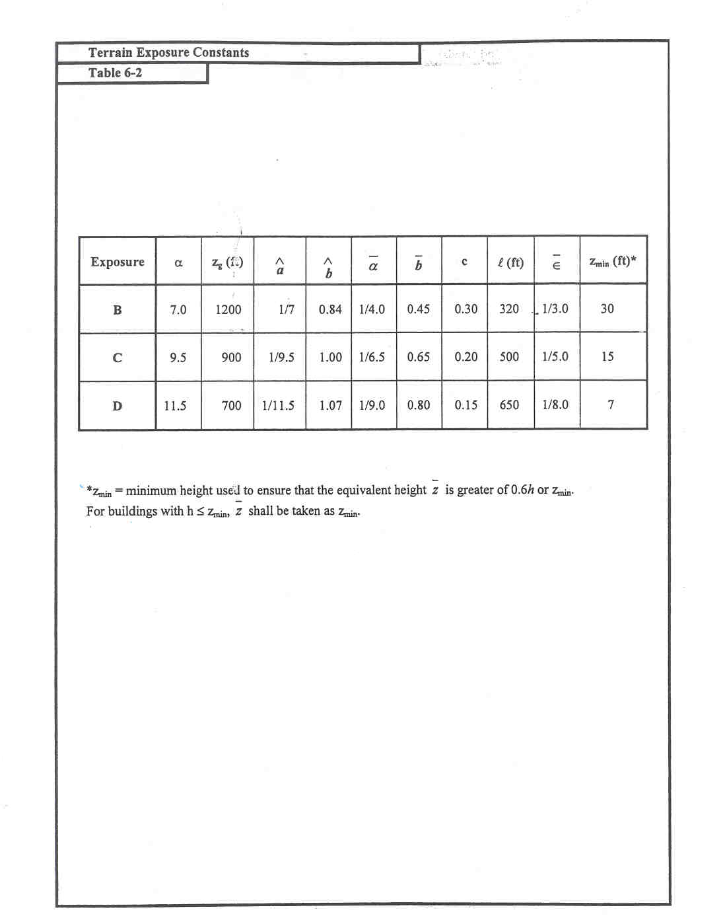

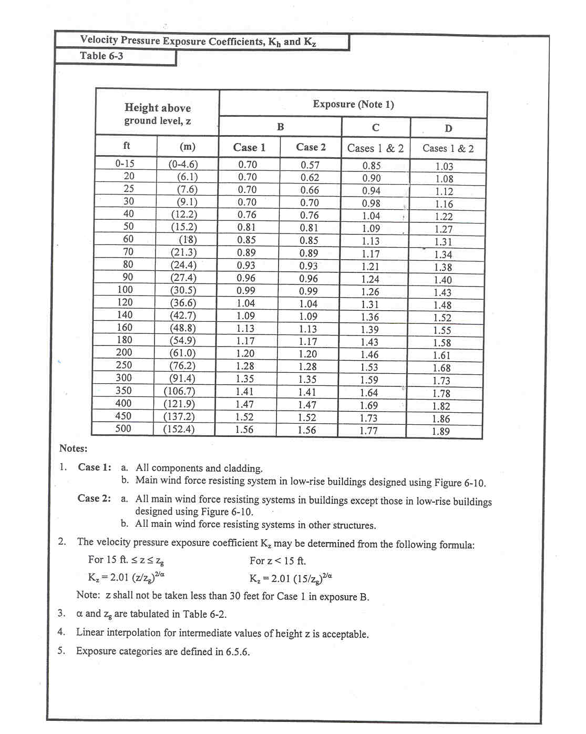
Note: Section 6.5.6 of ASCE 7-02 corresponds to the section 4.2.12 of this Model Code
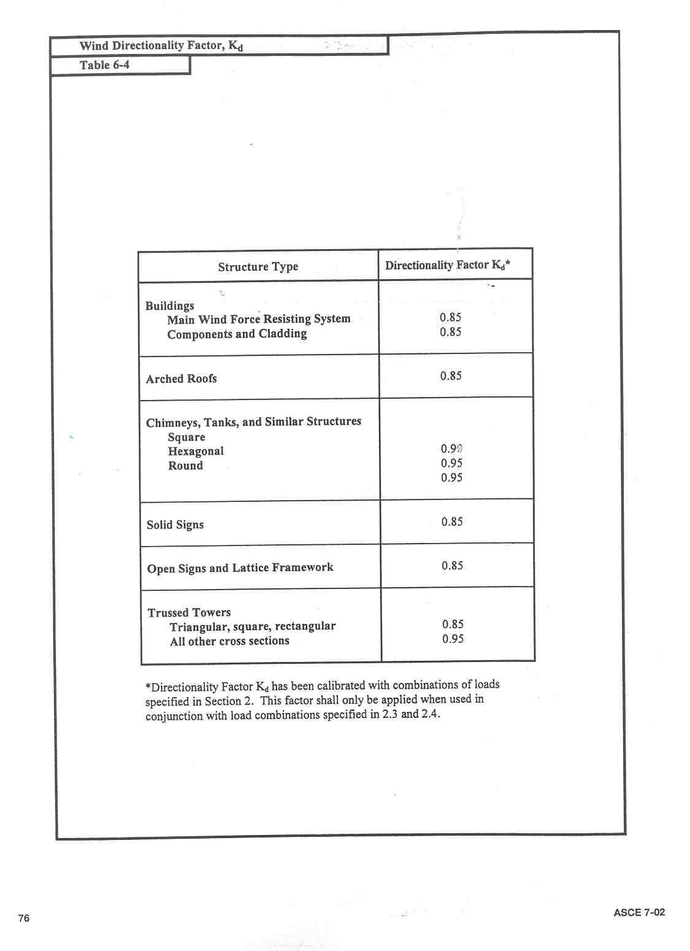
Note: Section 2 of ASCE 7-02 corresponds to the section 3.5 of this Model Code
Sections 2.3 and 2.4 correspond respectively to the sections 3.5.1 and 3.5.2 of this Model Code

Table 7-1
Classification of Buildings for Wind Loads

Nature of Occupancy | Category
Buildings and other structures that represent a low hazard to human life in the event of failure including, but not limited to:  - Agricultural facilities  - Certain temporary facilities  - Minor storage facilities  All buildings and other structures except those listed in Categories I, III and IV  Buildings and other structures that represent a substantial hazard to human life in the event of failure including, but not limited to:  - Buildings and other structures where more than 300 people congregate in one area  - Buildings and other structures with elementary school, secondary school or day-care facilities with capacity greater than 150  - Buildings and other structures with a capacity greater than 500 for colleges or adult education facilities  - Health care facilities with a capacity of 50 more resident patients but not having surgery or emergency treatment facilities  - Jails and detention facilities  - Power generating stations and other public utility facilities not included in Category IV  Buildings and other structures containing sufficient quantities of toxic, explosive or other hazardous substances to be dangerous to the public if released including, but not limited to:  - Petrochemical facilities  - Fuel storage facilities  - Manufacturing or storage facilities for hazardous chemicals  - Manufacturing or storage facilities for explosives  Buildings and other structures that are equipped with secondary containment of toxic, explosive or other hazardous substances (including, but not limited to double wall tank, dike of sufficient size to contain a spill or other means to contain a spill or blast within the property boundary of the facility and prevent release of harmful quantities of contaminants to the air, soil, ground water, or surface water) or atmosphere (where appropriate) shall be eligible for classification as Category II structure.  In hurricane prone regions, buildings and other structures that contain toxic, explosive, or other hazardous substances and do not qualify as Category IV structures shall be eligible for classification as Category II structures for wind loads if these structures are operated in accordance with mandatory procedures that are acceptable to the authority having jurisdiction and which effectively diminish the effects of wind on critical structural elements or which alternatively protect against harmful releases during and after hurricanes. | I  II  III
Buildings and other structures designated as essential facilities including, but not limited to:  - Hospitals and other health care facilities having surgery or emergency treatment facilities  - Fire, rescue and police stations and emergency vehicle garages  - Designated earthquake, hurricane, or other emergency shelters  - Communications centres and other facilities required for emergency response  - Power generating stations and other public utility facilities required in an emergency  - Ancillary structures (including, but not limited to communication towers, fuel storage tanks, cooling towers, electrical substation structures, fire water storage tanks or other structures housing or supporting water or other fire-suppression material or equipment) required for operation of Category IV structures during an emergency  - Aviation control towers, air traffic control centres and emergency aircraft hangers  - Water storage facilities and pump structures required to maintain water pressure for fire suppression  - Buildings and other structures having critical national defence functions | IV

Table 7-2
Importance Factor, I for Wind Loads

Category | Non-Hurricane Prone Regions  and Hurricane Prone Regions with  V = 137 – 161 km/h  (85 – 100 mph) | Hurricane Prone Regions with  V > 161 km/h  (100 mph)
I | 0.87 | 0.77
II | 1.00 | 1.00
III | 1.15 | 1.15
IV | 1.15 | 1.15

Note: The building and structure classification categories are listed in Table 7-1.

In this document, the ratio will always be considered as the geometric ratio or for the quotient

