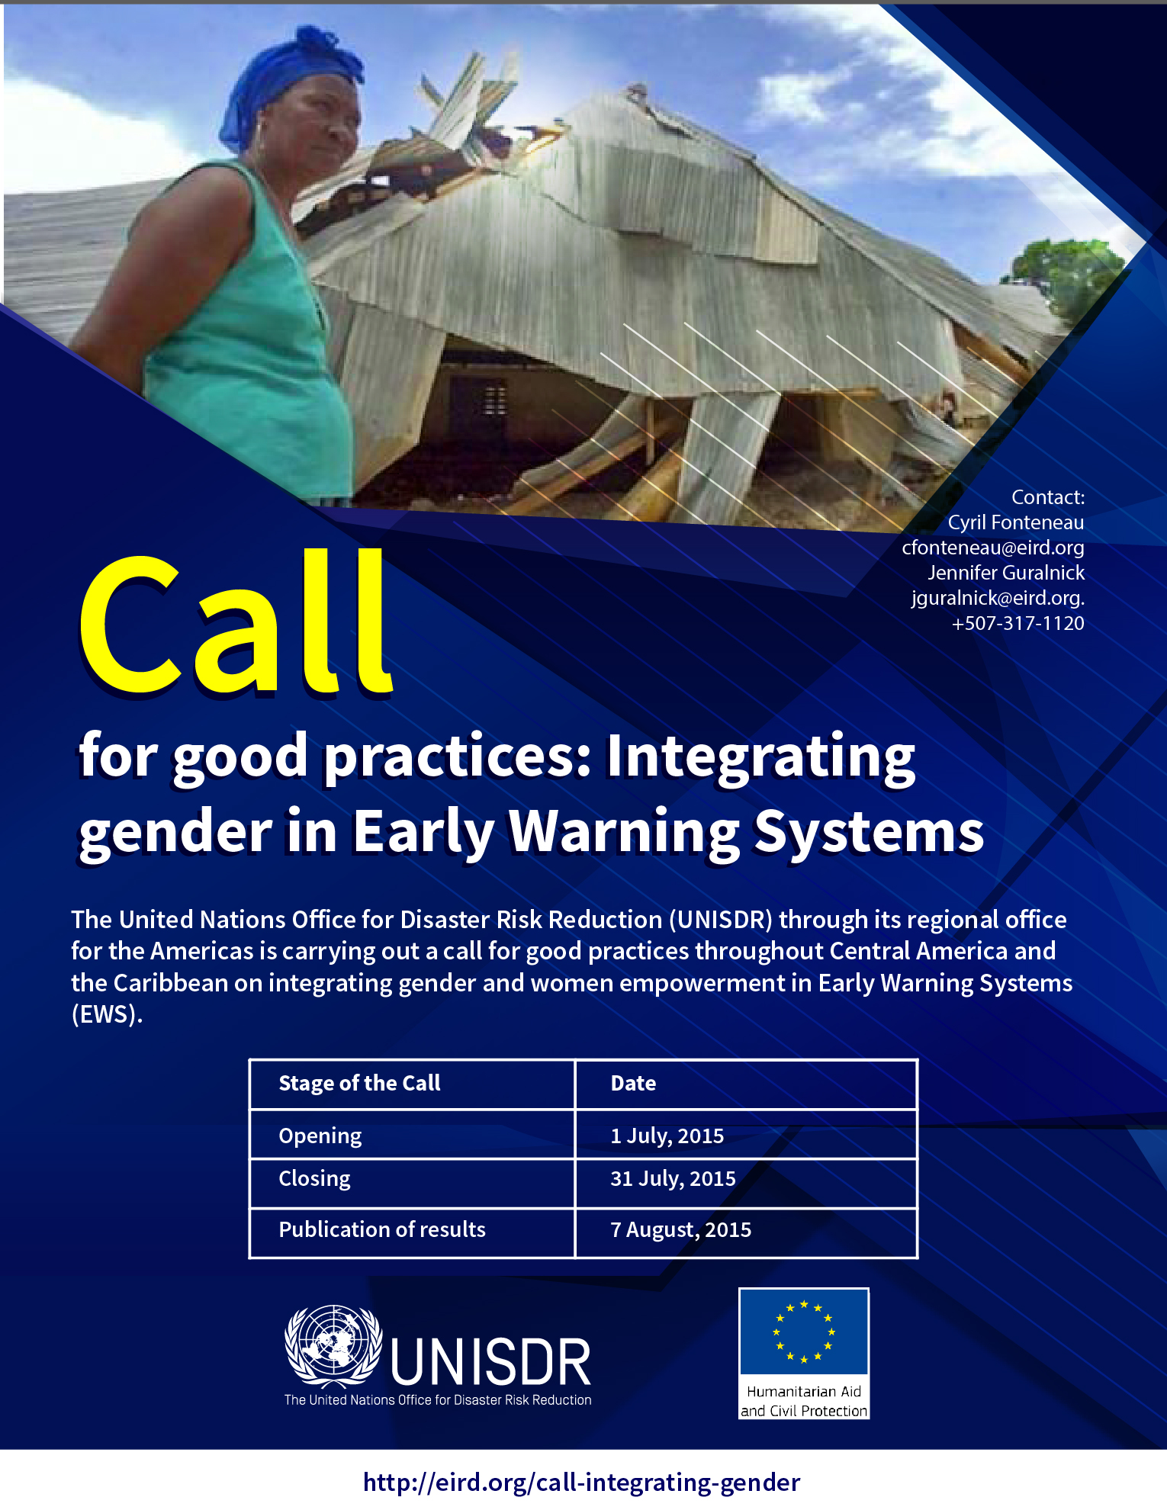

Application form

The presentation of the experience must be sent in Word format, Arial font 11, and should not exceed 2 pages. Previously a presentation of the candidate is necessary in the beginning of the project with the following information :

1. General information

Title of the experience
Country of where the experience occurred
Organization who presents
Name, Surname, and position of a contact
Telephone number (including the country code)
Email

2. The best practice

General background: to what need the project had achieved or tried to achieve?
Description : what was done?
To what extend this initiative is innovative?
Impact and means of verification: what were the results?

The key elements of the success: how (or if) it can be replicated?

3. Presentation of proposals

The project must be sent between the 1 to 30 of July 2015. The results will be published the 7 August, 2015.
Submit your proposals to and Cyril Fonteneau at cfonteneau@eird.org and Jennifer Guralnick jguralnick@eird.org

